Selenium Consolidated:

Questions:

1.Difference between driver.quit(); and driver.close();
- webDriver.Close() - Close the browser window that the driver has focus of
- webDriver.Quit() - Calls Dispose()
- webDriver.Dispose() Closes all browser windows and safely ends the session

2.What is webdriver?
Webdriver:
WebDriver is a remote control interface that enables introspection and control of user agents. It provides a platform- and language-neutral wire protocol as a way for out-of-process programs to remotely instruct the behavior of web browsers.
Provided is a set of interfaces to discover and manipulate DOM elements in web documents and to control the behavior of a user agent. It is primarily intended to allow web authors to write tests that automate a user agent from a separate controlling process, but may also be used in such a way as to allow in-browser scripts to control a — possibly separate — browser.
The standard forms part of the Web Testing Activity that authors a larger set of tools commonly used for testing.

https://www.seleniumhq.org/docs/03_webdriver.jsp - go through

For brief understanding:
https://www.w3.org/TR/webdriver/

3.What is WebDriver:
WebDriver is an interface that is version 2.0 of selenium.

4.How to invoke tests on browsers?
All browsers have different classes to invoke test.
All classes implement methods of WebDriver interface to enable the browsers to execute test cases.
 FirefoxDriver
 ChromeDriver
 InternetExplorerDriver
 SafariDriver
 EventFiringWebDriver
 HTMLUnitDriver
 RemoteWebDriver
// Instantiate the webdriver
WebDriver driver = new FirefoxDriver();
//Open the web application
driver.get(“http://www.google.com”)
3.x
WebDriver driver;
System.setProperty("webdriver.gecko.driver",/Users/atomar/Documents/workspace_personal/selenium/geckodriver");
driver = new FirefoxDriver();
String baseURL = "http://www.google.com";

driver.get(baseURL);

5.Object identification:
driver.findElement(By.id(locator));
driver.findElement(By.name(locator));
driver.findElement(By.xpath(locator));
driver.findElement(By.cssSelector(locator));
driver.findElement(By.linkText(locator));
driver.findElement(By.partialLinkText(locator));
driver.findElement(By.className(locator));
driver.findElement(By.tagName(locator));
List<WebElement> elementList = new ArrayList<WebElement>();
elementList = this.driver.findElements(By.id(locator));
// id - fastest
// name
// classname
// xpath
// linktext
// partial link text
// tagname
// css selector

6.Xpath syntax: //tagname[@attribute=’value’]
XPATH Cheat Sheet
Every element does not have an id --‐> static id, unique name, unique link text. For those elements we need to build xpath to find and then perform actions on them.
Whatever we use to find an element, id, name, xpath --‐> It should always be unique.
It should only find one matching node unless we want to capture a list of elements.
Difference between single ‘/’ or double ‘//’ Single slash ‘/’ anywhere in xpath signifies to look for the element immediately inside the parent element.
Double slash ‘//’ signifies to look for any child or nested--‐ child element inside the parent element.
Syntax:
//tag[@attribute='value']
Relative xpath using single ‘/’ for Login link
//div[@id='navbar']/div/div/div/ul/li[2]/a
Relative xpath using double ‘//’ for Login link.
//div[@id='navbar']//ul/li[2]/a
Don’t use “*”, always use the tag name. Using Text of the element to build xpath Finding Login link:
//div[@class='homepage--‐hero']//a[text()='Enroll now']
Using Contains to find the elements:
Syntax:
//tag[contains(attribute,‘value’)]
Finding Login link:
//div[@id='navbar']//a[contains(text(),'Login')]
//div[@id='navbar']//a[contains(@class,'navbar--‐link')
and
contains(@href,'sign_in')]
Using Starts--‐With to find the elements:
Syntax:
//tag[starts--‐with(attribute,‘value’)]
Finding Login link:
//div[@id='navbar']//a[starts--‐with(@class,'navbar--‐link')]
Parent Syntax:
xpath--‐to--‐some--‐element//parent::<tag>
Preceding Sibling Syntax:
xpath--‐to--‐some--‐element//preceding--‐sibling::<tag>
Following Sibling Syntax:
xpath--‐to--‐some--‐element//following--‐sibling::<tag>

7.Css:
tag[attribute='value']
“#”--‐>Id
“.”--‐>Class
Element Displayed Example Text Box:
input[id=displayed--‐text]
#displayed--‐text
input#displayed--‐text
input[class=displayed--‐class]
.displayed--‐class
input.displayed--‐class
Appending Classes
.class1.class2.class3 --‐> Until we find a unique element
Using wildcards in CSS Selectors:
“^”--‐> Represents the starting text
“$” --‐> Represents the ending text
“*” --‐> Represents the text contained
Syntax:
tag[attribute<special character>=’value’]

Examples:
input[class='inputs'] --‐> Only 1 matching node
input[class^='inputs'] --‐> Two matching nodes
input[class='displayed--‐class'] --‐ No matching nodes
input[class$='class'] --‐> One matching node
input[class*='displayed--‐class'] --‐> One matching node
Finding Children
Fieldset --‐> 10 matching nodes
Fieldset>table
fieldset>#product --‐> One matching node
fieldset>button --‐> One matching node
Fieldset>a
fieldset>input#name

8:JUNIT:
@BeforeClass
public static void setUpBeforeClass() throws Exception {
System.out.println("Executed before class...");
}

@AfterClass
public static void tearDownAfterClass() throws Exception {
System.out.println("Executed after class...");
}

@Before
public void setUp() throws Exception {
System.out.println("Executed before...");
}

@After
public void tearDown() throws Exception {
System.out.println("Executed after...");
}

@Test
public void test1() {
System.out.println("Executed Test1...");
}

@Test
public void test2() {
System.out.println("Executed Test2...");
}

9. Basic Actions:
driver.findElement(By.id(locator)).click();
driver.findElement(By.id(locator)). sendKeys("test");
driver.findElement(By.id(locator)). clear();
driver.findElement(By.id(locator)). getText();
driver.findElement(By.id(locator)). getAttribute("type");

Navigation:
driver.get(baseUrl);
String title = driver.getTitle();
String currentUrl = driver.getCurrentUrl();
driver.navigate().to(urlToNavigate);
driver.navigate().back();
driver.navigate().forward();
driver.navigate().refresh();
String pageSource = driver.getPageSource();

Element State:
driver.findElement(By.id(locator)). isEnabled();

Radio Button and Checkbox:
driver.findElement(By.id(locator)). click();
driver.findElement(By.id(locator)). isSelected();
boolean isChecked = false;

List<WebElement> radioButtons = driver.findElements(
By.xpath("//input[contains(@type,'radio') and contains(@name,'cars')]"));
int size = radioButtons.size();
System.out.println("Size of the list: " + size);
for (int i=0; i<size; i++) {
isChecked = radioButtons.get(i).isSelected();
if (!isChecked) {
radioButtons.get(i).click();
Thread.sleep(2000);
}
}

Dropdown Select:
WebElement element = driver.findElement(By.id("carselect"));
Select sel = new Select(element);
sel.selectByValue("benz");
sel.selectByIndex(2);
sel.selectByVisibleText("BMW");
List<WebElement> options = sel.getOptions();
int size = options.size();
for (int i=0; i<size; i++) {
String optionName = options.get(i).getText();
System.out.println(optionName);
}

Multiple Select:
sel.selectByValue("benz");
sel.selectByValue("benz");
sel.deselectByValue("orange");
sel.deselectAll();
sel.isMultiple();

JavaScript executor:
JavaScriptExecutor is an interface which provides mechanism to execute Javascript through selenium driver. It provides “executescript” & “executeAsyncScript” methods, to run JavaScript in the context of the currently selected frame or window. Lets inject Javascript into Browser using Selenium.

Scroll into view:
private JavascriptExecutor js;
js = (JavascriptExecutor) driver;
driver.findElement(By.id(locator)). isDisplayed();
js.executeScript("window.scrollBy(0, -190);");
// Scroll Down
js.executeScript("window.scrollBy(0, 1900);");
// Scroll Up
js.executeScript("window.scrollBy(0, -1900);");
// Scroll Element Into View
WebElement element = driver.findElement(By.id("mousehover"));
js.executeScript("arguments[0].scrollIntoView(true);", element);
Thread.sleep(2000);
js.executeScript("window.scrollBy(0, -190);");

Navigation:
// driver.get(baseUrl);
js.executeScript("window.location = https://letskodeit.teachable.com/pages/practice';");

// driver.get() method waits for the page to load completely before going to the next statement
// Adding Thread.sleep() because we are opening URL using js.executeScript() and it does not wait for the page to load completely
// If we do not add wait, then Selenium WebDriver will immediately try to find the element and it might have issues with just a little slow connection
Thread.sleep(3000);

Finding element:
// WebElement textBox = driver.findElement(By.id("name"));
WebElement textBox = (WebElement) js.executeScript("return document.getElementById('name');");
textBox.sendKeys("test");

Window Size:
long height = (Long) js.executeScript("return window.innerHeight;");
long width = (Long) js.executeScript("return window.innerWidth;");

Action Class:

MouseHoverActions:
WebElement mainElement = driver.findElement(By.id("mousehover"));
Actions action = new Actions(driver);
action.moveToElement(mainElement).perform();
action.moveToElement(subElement).click().perform();

Drag and drop:
//action.dragAndDrop(fromElement, toElement).build().perform();
// Click and hold, move to element, release, build and perform action.clickAndHold(fromElement).moveToElement(toElement).release().build().perform();

Sliders:
action.dragAndDropBy(element, 100, 0).perform();

Capturing screenshots:

Random string builder:
public static String getRandomString(int length) {
StringBuilder sb = new StringBuilder();
String characters = "abcdefghijklmnopqrstuvwxyzABCDEFGHIJKLMNOPQRSTUVWXYZ1234567890";
for (int i = 0; i < length; i++) {
int index = (int) (Math.random() * characters.length());
sb.append(characters.charAt(index));
}
return sb.toString();
}

Screenshot:
String fileName = getRandomString(10) + ".png";
String directory = "//Users//anil.tomar//Desktop//";
File sourceFile = ((TakesScreenshot)driver).getScreenshotAs(OutputType.FILE);
FileUtils.copyFile(sourceFile, new File(directory + fileName));
driver.quit();
or:
public static void takeSnapShot(WebDriver webdriver,String fileWithPath) throws Exception{

//Convert web driver object to TakeScreenshot

TakesScreenshot scrShot =((TakesScreenshot)webdriver);

//Call getScreenshotAs method to create image file

File SrcFile=scrShot.getScreenshotAs(OutputType.FILE);

//Move image file to new destination

File DestFile=new File(fileWithPath);

//Copy file at destination

FileUtils.copyFile(SrcFile, DestFile);

}

Switch Window:
String parentHandle = driver.getWindowHandle();
Set<String> handles = driver.getWindowHandles();
for (String handle: handles) {
System.out.println(handle);
}
driver.switchTo().window(handle);

Switch frame:
driver.switchTo().frame("courses-iframe");
driver.switchTo().defaultContent();
driver.switchTo().frame(0);

Sync/Waits:

Implicit wait:
WebDriver driver = new FirefoxDriver();
driver.manage().timeouts().implicitlyWait(10, TimeUnit.SECONDS);

Explicit wait:
WebDriverWait wait = new WebDriverWait(driver, 10);
WebElement element = wait.until(ExpectedConditions.elementToBeClickable(By.id("someid")));

Expected conditions:
These are the available expected conditions:
alertIsPresent
 elementSelectionStateToBe
 elementToBeClickable
 elementToBeSelected
 frameToBeAvailableAndSwitchToIt
 invisibilityOfElementLocated
 presenceOfElementLocated
 textToBePresentInElementLocated
 textToBePresentInElementValue
 titleContains
 titles
 visibilityOfElementLocated
All Expected Conditions:
https://seleniumhq.github.io/selenium/docs/api/java/org/openqa/selenium/support/ui/ExpectedConditions.html

Fluent Wait:
// Waiting 30 seconds for an element to be present on the page, checking
// for its presence once every 5 seconds.
Wait wait = new FluentWait(driver)
.withTimeout(30, SECONDS)
.pollingEvery(5, SECONDS)
.ignoring(NoSuchElementException.class);
WebElement foo = wait.until(new Function() {
public WebElement apply(WebDriver driver) {
return driver.findElement(By.id("foo"));
}
});

Calender Selection:

JavaScriptAlertHandling:
Alert alert = driver.switchTo().alert();
alert.accept();
alert.dismiss();

Excel handling:

Create Excel:
String filePathH = "D:\\workspace\\TestSheet.xls";
String filePathX = "D:\\workspace\\TestSheet1.xls";
// String fileName = "TestSheet.xls";

Workbook wbh = new HSSFWorkbook();
Sheet sheet1 = wbh.createSheet("Test");
try{
FileOutputStream fileout = new FileOutputStream(filePathH);
wbh.write(fileout);
fileout.close();
} catch(Exception E){
System.out.println("Could not create excel file");

}

Workbook wbx = new XSSFWorkbook();
Sheet sheet2 = wbx.createSheet("Test");
try{
FileOutputStream fileoutx = new FileOutputStream(filePathX);
wbx.write(fileoutx);
fileoutx.close();
} catch(Exception E){
System.out.println("Could not create excel file");

}

String filePath = "D:\\workspace";
String fileName = "New Microsoft Excel Worksheet.xlsx";
// Call read file method of the class to read data
String sheetName = "Sheet1";
String[] dataToWrite = { "Mr.F", "India" };
objExcelFile.readExcel(filePath, fileName, sheetName);
File file = new File(filePath + "\\" + fileName);
FileInputStream inputStream = new FileInputStream(file);
Workbook xlWorkbook = null;
String fileExtenstion = fileName.substring(fileName.indexOf("."));
if (fileExtenstion.equals(".xls")) {
xlWorkbook = new HSSFWorkbook(inputStream);
} else if (fileExtenstion.equals(".xlsx")) {
xlWorkbook = new XSSFWorkbook(inputStream);
}

Sheet xlWorksheet = xlWorkbook.getSheet(sheetName);
int rowCount = xlWorksheet.getLastRowNum() - xlWorksheet.getFirstRowNum();
for (int i = 0; i < rowCount + 1; i++) {
Row row = xlWorksheet.getRow(i);
for (int j = 0; j < row.getLastCellNum(); j++) {
System.out.println(row.getCell(j).getStringCellValue());
}

}
// Read excel sheet by sheet name
// Sheet sheet = xlWorkbook.getSheet(sheetName);
// Get the current count of rows in excel file
int rowCount1 = xlWorksheet.getLastRowNum() - xlWorksheet.getFirstRowNum();
// Get the first row from the sheet
Row row = xlWorksheet.getRow(0);
// Create a new row and append it at last of sheet
Row newRow = xlWorksheet.createRow(rowCount1 + 1);
// Create a loop over the cell of newly created Row
for (int j = 0; j < row.getLastCellNum(); j++) {
// Fill data in row
Cell cell = newRow.createCell(j);
cell.setCellValue(dataToWrite[j]);
}
inputStream.close();
//Create an object of FileOutputStream class to create write data in excel file
FileOutputStream outputStream = new FileOutputStream(file);
//write data in the excel file
xlWorkbook.write(outputStream);
//close output stream
outputStream.close();
}

XML Reading:
public String ReadFile(String fileName,String id)
{

String testinput = null;
String projectPath=System.getProperty("user.dir");
System.out.println(projectPath);
File fXmlFile = new File("D:\\Users\\achyut.k\\Desktop\\TestCases.xml");//projectPath+File.separator+fileName
System.out.println(fXmlFile);
DocumentBuilderFactory dbFactory = DocumentBuilderFactory.newInstance();
DocumentBuilder dBuilder = null;
try {
dBuilder = dbFactory.newDocumentBuilder();
} catch (ParserConfigurationException e) {
e.printStackTrace();
}
Document doc= null;
try {
doc = dBuilder.parse(fXmlFile);
} catch (SAXException e) {
e.printStackTrace();
} catch (IOException e) {
e.printStackTrace();
}
System.out.println("Root element :" + doc.getDocumentElement().getNodeName());
XPath xPath = XPathFactory.newInstance().newXPath();
String expression = String.format("/TestCases/Test[@id='"+id+"']/TestModule");
System.out.println(expression);
Node node = null;
try {
node = (Node) xPath.compile(expression).evaluate(doc, XPathConstants.NODE);
} catch (XPathExpressionException e) {
e.printStackTrace();
}
testinput = node != null ? (node.getTextContent()) : "cannot read the test case xml file";
return testinput;

}

Reading data from Config file:
public String GetConfigData(String parametername){

Properties Configuration = new Properties();
InputStream input = null;
String data = null;
try {
input = new FileInputStream("src\\commonUtils\\Configuration.properties");
Configuration.load(input);
data = (Configuration.getProperty(parametername));
} catch (IOException exp) {
exp.printStackTrace();
} finally {
if (input != null) {
try {
input.close();
} catch (IOException e) {
e.printStackTrace();
}
}
}
return data;
}

DB:
public ResultSet GetDBdata(String myquery) throws Exception{
Connection con = null;
Statement stmt = null;
String DB_URL = GetConfigData("DBhostname");
//"jdbc:oracle:thin:@psdssub-ora.cs.boeing.com:1521:psds05";
String DB_USER = GetConfigData("DBusername");
String DB_PASSWORD = GetConfigData("DBpassword");
String query = myquery;
ResultSet res = null;
//connect to DB
try {
String dbClass = "oracle.jdbc.driver.OracleDriver";
System.out.println("Connecting to database...");
Class.forName(dbClass).newInstance();
con = DriverManager.getConnection(DB_URL, DB_USER, DB_PASSWORD);
log.debug("Connected to the database");
stmt = con.createStatement();
}catch (SQLException e) {
con.close();
log.debug("\n Closed connection to the database");
e.printStackTrace();
}
//Execute query
try {
res = stmt.executeQuery(query);
}catch (Exception e) {
con.close();
log.debug("\nClosed connection to the database");
e.printStackTrace();
}
//Close DB connection
try {
con.close();
log.debug("\nClosed connection to the database");
} catch (Exception e) {
log.debug("Error closing connection to the database");
e.printStackTrace();
}
return res;
}
------------------------------------------------------------------------------------
String dbClass = "oracle.jdbc.driver.OracleDriver";
Class.forName(dbClass).newInstance();
Connection con = DriverManager.getConnection(DB_URL, DB_USER, DB_PASSWORD);
Statement stmt = con.createStatement();
ResultSet res = stmt.executeQuery(query);

------------------------------------------------------------------------------------

AJAX Calls:
//To wait until page loaded AJAX_CALLS
public static final ExpectedCondition<Boolean> WAIT_FOR_AJAX_CALLS_TO_COMPLETE = new ExpectedCondition<Boolean>() {
@Override
public Boolean apply(WebDriver driver) {

Boolean result;
try {
result = (Boolean) ((JavascriptExecutor) driver).executeScript("return jQuery.active == 0");
} catch (Exception ex) {
result = Boolean.FALSE;
}
return result;
}
};

Auto IT:
Need to install Autoit and SciTE Editor. Install 86X(32 bit version).
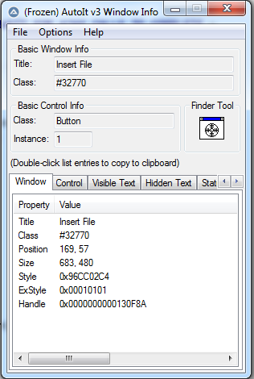
Editor:
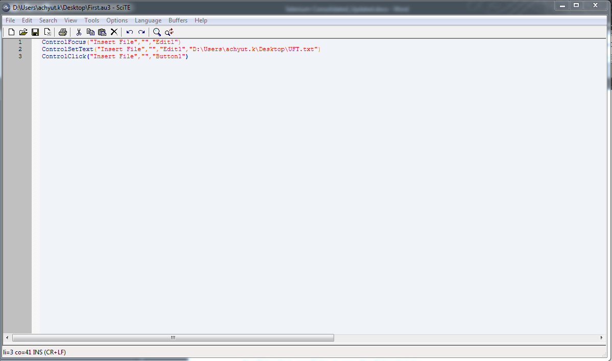

Controls
One of the best features with AutoIt v3 is the ability to work directly with certain types of Window Controls. Almost everything you see on a window is a control of some kind. Buttons, listboxes, edit fields and static text are all examples of controls. In fact, Notepad is just one big "Edit" control! Because AutoIt works directly with a control, they provide a more reliable way to automate than just sending keystrokes.

Note: AutoIt only works with standard Microsoft controls. Some applications write their own custom controls which may look like a standard MS control but may resist automation. Experiment!

Using the AutoIt Window Info Tool you can move your mouse around the window you are interested in and you will be given information of the control that is currently under your mouse.
A special description can be used as the controlID parameter used in most of the Control...() functions. This description can be used to identify a control by the following properties:
- ID - The internal control ID. The Control ID is the internal numeric identifier that windows gives to each control. It is generally the best method of identifying controls. In addition to the AutoIt Window Info Tool, other applications such as screen readers for the blind and Microsoft tools/APIs may allow you to get this Control ID
- TEXT - The text on a control, for example "&Next" on a button
- CLASS - The internal control classname such as "Edit" or "Button"
- CLASSNN - The ClassnameNN value as used in previous versions of AutoIt, such as "Edit1"
- NAME - The internal .NET Framework WinForms name (if available)
- REGEXPCLASS - Control classname using a regular expression
- X \ Y \ W \ H - The position and size of a control.
- INSTANCE - The 1-based instance when all given properties match.
One or more properties are used in the controlID parameter of a control command in the format:
[PROPERTY1 : Value1; PROPERTY2:Value2]
Note: If this special format is not used then the parameter is taken to be a control ID (if numeric) or the ClassnameNN/text of the control (if a string). Although the special format is more long-winded than these methods it is much less ambiguous.
If a Value must contain a ";" it must be doubled.

e.g. Send text to the 1st Edit control in the Notepad window
ControlSend("Untitled - Notepad", "", "[CLASS:Edit; INSTANCE:1]", "This is some text")
or
ControlSend("Untitled - Notepad", "", "[CLASSNN:Edit1]", "This is some text")
or
ControlSend("Untitled - Notepad", "", "Edit1", "This is some text")

e.g. Click on control ID 254 in "My Window"
ControlClick("My Window", "", "[ID:254]")
or
ControlClick("My Window", "", 254)

e.g. Set the text of the .NET Winforms "textBoxFolder" control to "C:\Some\Folder"
ControlSetText("My Window", "", "[NAME:textBoxFolder]", "C:\Some\Folder")

e.g. Click the 2nd instance of a "Button" control containing the text "Finish"
ControlClick("My Window", "", "[CLASS:Button; TEXT:Finish; INSTANCE:2]")

Control Handle (HWND)
Using the ControlGetHandle function you can determine the Handle or HWND of a control. A handle is the unique identifier that Windows gives controls. The handle changes each time the control is created. This method of accessing controls is generally only designed for users who are familiar with working with handles.

Look under the contents for Function Reference \ Window Management \ Controls for a list of the functions that work with controls.

In selenium:
Runtime.getRuntime().exec("D:\\Users\\achyut.k\\Desktop\\First.exe");

Robot Class:
Robot robot=new Robot();

Methods under Robot Class are:
- .keyPress();
- .mousePress();
- .mouseMove();
- .keyRelease();
- .mouseRelease();

Press Escape key on keyboard using Different Robot class Methods:

- .keyPress()
- Using keyPress() Method we Press any key from KeyBoard.
1  2  3 | // This will press Escape key on keyboard.  robot.keyPress(KeyEvent.VK_ESC);
- .keyRelease()
- Using keyRelease() Method we Release the Pressed any key from KeyBoard.
1  2  3 | // This will release the CAPS_LOCK key.  robot.keyRelease(KeyEvent.VK_CAPS_LOCK);
- .mousePress()
- Using mousePress() Method we press Left mouse button from Mouse.
1  2  3 | // This will press Left mouse button.  robot.mousePress(InputEvent.BUTTON1_MASK);
- .mouseRelease()
- Using mouseRelease() Method we Release pressed Left mouse button from Mouse.
1  2  3 | // This will release Left mouse button.  robot.mouseRelease(InputEvent.BUTTON1_MASK);
- .mouseMove()
- Using mouseMove() Method use to Move cursor pointer to X and Y co-ordinates.
1  2  3 | //This will move the mouse pointer to X and Y co-ordinates.  robot.mouseMove(coordinates.getX(), coordinates.getY());

Note: keyPress will send an event that a key has been pressed down. keyRelease will send the event that the key has been released .

Steps to Press Escape key on keyboard Robot class:
- Create object of Robot class.
- Using keyPress method press Escape key from KeyBoard.
- Using keyRelease method release the CAPS_LOCK key.
- Using mousePress Method press Left mouse button.
- Using mouseRelease Method release the Left mouse button.
- Using getLocation() method Get Location and using mouseMove(coordinates.getX(), coordinates.getY() method move mouse on X,Y Co-Ordinate.
robot.keyPress(KeyEvent.VK_META); - Windows key

TestNG:

Asserts: - It will not run if assert fails
Assert.assertEquals(Actual,expected)
Soft Asserts: - It wil run even after assert fails
SoftAssert sa = new SoftAssert();
sa.assertEquals(Actual,expected); - but it will not report it as failure
sa.assertAll(); - but after adding thiss statement all failures will be reported.

Annotations:
@BeforeSuite: The annotated method will be run once before all tests in this suite have run.
@AfterSuite: The annotated method will be run once after all tests in this suite have run.
@BeforeTest: The annotated method will be run before any test method belonging to the classes inside the tag is run.
@AfterTest: The annotated method will be run after all the test methods belonging to the classes inside the tag have run.
@BeforeGroups: The list of groups that this configuration method will run before. This method is guaranteed to run shortly before the first test method that belongs to any of these groups is invoked.
@AfterGroups: The list of groups that this configuration method will run after. This method is guaranteed to run shortly after the last test method that belongs to any of these groups is invoked.
@BeforeClass: The annotated method will be run before the first test method in the current class is invoked.
@AfterClass: The annotated method will be run after all the test methods in the current class have been run.
@BeforeMethod: The annotated method will be run before each test method.
@AfterMethod: The annotated method will be run after each test method.
@Test: The annotated method is a part of a test case.

Execution order:
Before suite
Before Test
Before class
Before Method
Test Method
AFter Method
After class
AFter Test
PASSED: testMethod

@BeforeClass (groups = {"first Test","second Test"},dependsOnMethods = {"beforeSuite"},)
public void beforeClass() {
System.out.println("Before class");
}

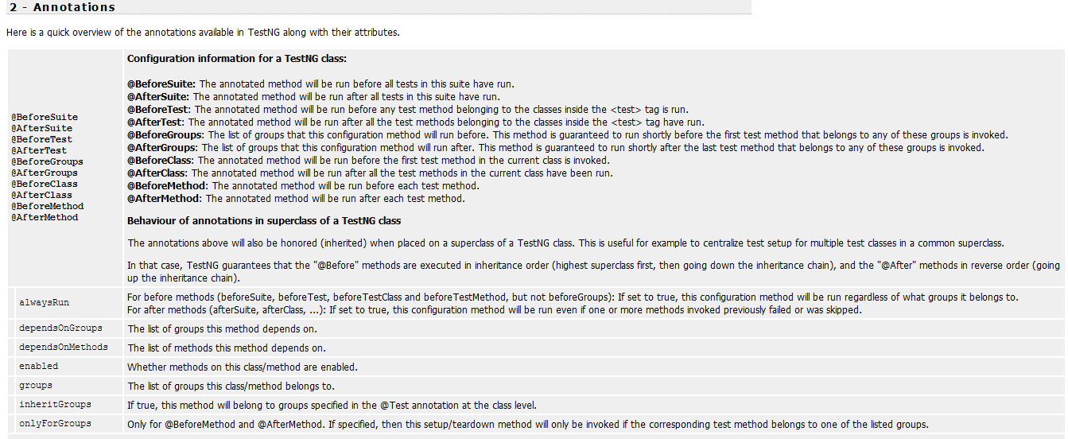

alwaysRun | For before methods (beforeSuite, beforeTest, beforeTestClass and beforeTestMethod, but not beforeGroups): If set to true, this configuration method will be run regardless of what groups it belongs to.  For after methods (afterSuite, afterClass, ...): If set to true, this configuration method will be run even if one or more methods invoked previously failed or was skipped.
 | dependsOnGroups | The list of groups this method depends on.
 | dependsOnMethods | The list of methods this method depends on.
 | enabled | Whether methods on this class/method are enabled.
 | groups | The list of groups this class/method belongs to.
 | inheritGroups | If true, this method will belong to groups specified in the @Test annotation at the class level.
 | onlyForGroups | Only for @BeforeMethod and @AfterMethod. If specified, then this setup/teardown method will only be invoked if the corresponding test method belongs to one of the listed groups.
@DataProvider |  | Marks a method as supplying data for a test method. The annotated method must return an Object[][] where each Object[] can be assigned the parameter list of the test method. The @Test method that wants to receive data from this DataProvider needs to use a dataProvider name equals to the name of this annotation.
 | name | The name of this data provider. If it's not supplied, the name of this data provider will automatically be set to the name of the method.
 | parallel | If set to true, tests generated using this data provider are run in parallel. Default value is false.
@Factory |  | Marks a method as a factory that returns objects that will be used by TestNG as Test classes. The method must return Object[].
@Listeners |  | Defines listeners on a test class.
 | value | An array of classes that extend org.testng.ITestNGListener.
@Parameters |  | Describes how to pass parameters to a @Test method.
 | value | The list of variables used to fill the parameters of this method.

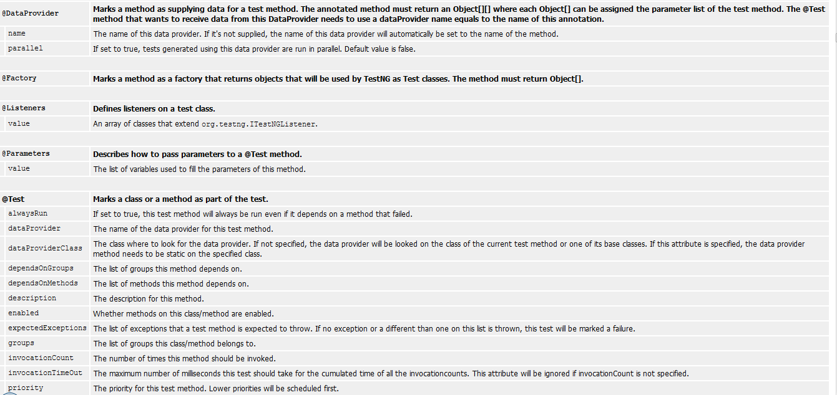

@Test |  | Marks a class or a method as part of the test.
 | alwaysRun | If set to true, this test method will always be run even if it depends on a method that failed.
 | dataProvider | The name of the data provider for this test method.
 | dataProviderClass | The class where to look for the data provider. If not specified, the data provider will be looked on the class of the current test method or one of its base classes. If this attribute is specified, the data provider method needs to be static on the specified class.
 | dependsOnGroups | The list of groups this method depends on.
 | dependsOnMethods | The list of methods this method depends on.
 | description | The description for this method.
 | enabled | Whether methods on this class/method are enabled.
 | expectedExceptions | The list of exceptions that a test method is expected to throw. If no exception or a different than one on this list is thrown, this test will be marked a failure.
 | groups | The list of groups this class/method belongs to.
 | invocationCount | The number of times this method should be invoked.
 | invocationTimeOut | The maximum number of milliseconds this test should take for the cumulated time of all the invocationcounts. This attribute will be ignored if invocationCount is not specified.
 | priority | The priority for this test method. Lower priorities will be scheduled first.
 | successPercentage | The percentage of success expected from this method
 | singleThreaded | If set to true, all the methods on this test class are guaranteed to run in the same thread, even if the tests are currently being run with parallel="methods". This attribute can only be used at the class level and it will be ignored if used at the method level. Note: this attribute used to be called sequential (now deprecated).
 | timeOut | The maximum number of milliseconds this test should take.
 | threadPoolSize | The size of the thread pool for this method. The method will be invoked from multiple threads as specified by invocationCount.  Note: this attribute is ignored if invocationCount is not specified

Refrences: http://testng.org/doc/documentation-main.html

TESTNG formats:

testng.xml:

Normal:
<!DOCTYPE suite SYSTEM "http://testng.org/testng-1.0.dtd" >

<suite name="Suite1" verbose="1" >
<test name="Nopackage" >

<classes>
<class name="NoPackageTest" />

</classes>
</test>

<test name="Regression1">

<classes>
<class name="test.sample.ParameterSample"/>

<class name="test.sample.ParameterTest"/>
</classes>

</test>
</suite>

Package execution:
<!DOCTYPE suite SYSTEM "http://testng.org/testng-1.0.dtd" >

<suite name="Suite1" verbose="1" >
<test name="Regression1" >

<packages>
<package name="test.sample" />

</packages>
</test>

</suite>
In this example, TestNG will look at all the classes in the package test.sample and will retain only classes that have TestNG annotations.

Groups and methods:
<test name="Regression1">
<groups>

<run>
<exclude name="brokenTests" />

<include name="checkinTests" />
</run>

</groups>

<classes>
<class name="test.IndividualMethodsTest">

<methods>
<include name="testMethod" />

</methods>
</class>

</classes>
</test>

You can also define new groups inside testng.xml and specify additional details in attributes, such as whether to run the tests in parallel, how many threads to use, whether you are running JUnit tests, etc...
By default, TestNG will run your tests in the order they are found in the XML file. If you want the classes and methods listed in this file to be run in an unpredictable order, set the preserve-order attribute to false
<test name="Regression1" preserve-order="false">
<classes>

<class name="test.Test1">

<methods>
<include name="m1" />

<include name="m2" />
</methods>

</class>

<class name="test.Test2" />

</classes>
</test>

Test Methods, test classes and test groups:
Test methods are annotated with @Test. Methods annotated with @Test that happen to return a value will be ignored, unless you set allow-return-values to true in your testng.xml:
<suite allow-return-values="true">

or

<test allow-return-values="true">

Test groups:
TestNG allows you to perform sophisticated groupings of test methods. Not only can you declare that methods belong to groups, but you can also specify groups that contain other groups. Then TestNG can be invoked and asked to include a certain set of groups (or regular expressions) while excluding another set. This gives you maximum flexibility in how you partition your tests and doesn't require you to recompile anything if you want to run two different sets of tests back to back.
Groups are specified in your testng.xml file and can be found either under the <test> or <suite> tag. Groups specified in the <suite> tag apply to all the <test> tags underneath. Note that groups are accumulative in these tags: if you specify group "a" in <suite> and "b" in <test>, then both "a" and "b" will be included.
For example, it is quite common to have at least two categories of tests
- Check-in tests. These tests should be run before you submit new code. They should typically be fast and just make sure no basic functionality was broken.
- Functional tests. These tests should cover all the functionalities of your software and be run at least once a day, although ideally you would want to run them continuously.
Typically, check-in tests are a subset of functional tests. TestNG allows you to specify this in a very intuitive way with test groups. For example, you could structure your test by saying that your entire test class belongs to the "functest" group, and additionally that a couple of methods belong to the group "checkintest":
public class Test1 {
@Test(groups = { "functest", "checkintest" })

public void testMethod1() {
}

@Test(groups = {"functest", "checkintest"} )

public void testMethod2() {
}

@Test(groups = { "functest" })

public void testMethod3() {
}

}
Invoking TestNG with
<test name="Test1">
<groups>

<run>
<include name="functest"/>

</run>
</groups>

<classes>
<class name="example1.Test1"/>

</classes>
</test>
will run all the test methods in that classes, while invoking it with checkintest will only run testMethod1() and testMethod2().
Here is another example, using regular expressions this time. Assume that some of your test methods should not be run on Linux, your test would look like:
@Test
public class Test1 {

@Test(groups = { "windows.checkintest" })
public void testWindowsOnly() {

}

@Test(groups = {"linux.checkintest"} )
public void testLinuxOnly() {

}

@Test(groups = { "windows.functest" )
public void testWindowsToo() {

}
}
You could use the following testng.xml to launch only the Windows methods:
<test name="Test1">
<groups>

<run>
<include name="windows.*"/>

</run>
</groups>

<classes>

<class name="example1.Test1"/>
</classes>

</test>
Note: TestNG uses regular expressions, and not wildmats. Be aware of the difference (for example, "anything" is matched by ".*" -- dot star -- and not "*").

Method groups
You can also exclude or include individual methods:
<test name="Test1">
<classes>

<class name="example1.Test1">
<methods>

<include name=".*enabledTestMethod.*"/>
<exclude name=".*brokenTestMethod.*"/>

</methods>
</class>

</classes>
</test>
This can come in handy to deactivate a single method without having to recompile anything, but I don't recommend using this technique too much since it makes your testing framework likely to break if you start refactoring your Java code (the regular expressions used in the tags might not match your methods any more).

Groups of group:
Groups can also include other groups. These groups are called "MetaGroups". For example, you might want to define a group "all" that includes "checkintest" and "functest". "functest" itself will contain the groups "windows" and "linux" while "checkintest will only contain "windows". Here is how you would define this in your property file:
<test name="Regression1">
<groups>

<define name="functest">
<include name="windows"/>

<include name="linux"/>
</define>

<define name="all">

<include name="functest"/>
<include name="checkintest"/>

</define>

<run>
<include name="all"/>

</run>
</groups>

<classes>

<class name="test.sample.Test1"/>
</classes>

</test>

Exclusion groups:

TestNG allows you to include groups as well as exclude them.
For example, it is quite usual to have tests that temporarily break because of a recent change, and you don't have time to fix the breakage yet. 4 However, you do want to have clean runs of your functional tests, so you need to deactivate these tests but keep in mind they will need to be reactivated.
A simple way to solve this problem is to create a group called "broken" and make these test methods belong to it. For example, in the above example, I know that testMethod2() is now broken so I want to disable it:
@Test(groups = {"checkintest", "broken"} )
public void testMethod2() {

}
All I need to do now is to exclude this group from the run:
<test name="Simple example">
<groups>

<run>
<include name="checkintest"/>

<exclude name="broken"/>
</run>

</groups>

<classes>
<class name="example1.Test1"/>

</classes>
</test>
This way, I will get a clean test run while keeping track of what tests are broken and need to be fixed later.
Note: you can also disable tests on an individual basis by using the "enabled" property available on both @Test and @Before/After annotations.

Partial groups:
You can define groups at the class level and then add groups at the method level:
@Test(groups = { "checkin-test" })
public class All {

@Test(groups = { "func-test" )

public void method1() { ... }

public void method2() { ... }
}
In this class, method2() is part of the group "checkin-test", which is defined at the class level, while method1() belongs to both "checkin-test" and "func-test".

Parameters:
Test methods don't have to be parameterless. You can use an arbitrary number of parameters on each of your test method, and you instruct TestNG to pass you the correct parameters with the @Parameters annotation.
There are two ways to set these parameters: with testng.xml or programmatically.

Using testing xml:
If you are using simple values for your parameters, you can specify them in your testng.xml:
@Parameters({ "first-name" })
@Test

public void testSingleString(String firstName) {
System.out.println("Invoked testString " + firstName);

assert "Cedric".equals(firstName);
}
In this code, we specify that the parameter firstName of your Java method should receive the value of the XML parameter called first-name. This XML parameter is defined in testng.xml:
<suite name="My suite">
<parameter name="first-name" value="Cedric"/>

<test name="Simple example">
<-- ... -->
The same technique can be used for @Before/After and @Factory annotations:
@Parameters({ "datasource", "jdbcDriver" })
@BeforeMethod

public void beforeTest(String ds, String driver) {
m_dataSource = ...; // look up the value of datasource

m_jdbcDriver = driver;
}
This time, the two Java parameter ds and driver will receive the value given to the properties datasource and jdbc-driver respectively.
Parameters can be declared optional with the Optional annotation:
@Parameters("db")
@Test

public void testNonExistentParameter(@Optional("mysql") String db) { ... }
If no parameter named "db" is found in your testng.xml file, your test method will receive the default value specified inside the @Optional annotation: "mysql".
The @Parameters annotation can be placed at the following locations:
- On any method that already has a @Test, @Before/After or @Factory annotation.
- On at most one constructor of your test class. In this case, TestNG will invoke this particular constructor with the parameters initialized to the values specified in testng.xml whenever it needs to instantiate your test class. This feature can be used to initialize fields inside your classes to values that will then be used by your test methods.
Notes:
- The XML parameters are mapped to the Java parameters in the same order as they are found in the annotation, and TestNG will issue an error if the numbers don't match.
- Parameters are scoped. In testng.xml, you can declare them either under a <suite> tag or under <test>. If two parameters have the same name, it's the one defined in <test> that has precedence. This is convenient if you need to specify a parameter applicable to all your tests and override its value only for certain tests.

Dataproviders:
Specifying parameters in testng.xml might not be sufficient if you need to pass complex parameters, or parameters that need to be created from Java (complex objects, objects read from a property file or a database, etc...). In this case, you can use a Data Provider to supply the values you need to test. A Data Provider is a method on your class that returns an array of array of objects. This method is annotated with @DataProvider:
//This method will provide data to any test method that declares that its Data Provider
//is named "test1"

@DataProvider(name = "test1")
public Object[][] createData1() {

return new Object[][] {
{ "Cedric", new Integer(36) },

{ "Anne", new Integer(37)},
};

}

//This test method declares that its data should be supplied by the Data Provider
//named "test1"

@Test(dataProvider = "test1")
public void verifyData1(String n1, Integer n2) {

System.out.println(n1 + " " + n2);
}
will print
Cedric 36
Anne 37
A @Test method specifies its Data Provider with the dataProvider attribute. This name must correspond to a method on the same class annotated with @DataProvider(name="...") with a matching name.
By default, the data provider will be looked for in the current test class or one of its base classes. If you want to put your data provider in a different class, it needs to be a static method or a class with a non-arg constructor, and you specify the class where it can be found in the dataProviderClass attribute:
public class StaticProvider {
@DataProvider(name = "create")

public static Object[][] createData() {
return new Object[][] {

new Object[] { new Integer(42) }
};

}
}

public class MyTest {

@Test(dataProvider = "create", dataProviderClass = StaticProvider.class)
public void test(Integer n) {

// ...
}

}
The data provider supports injection too. TestNG will use the test context for the injection. The Data Provider method can return one of the following two types:
- An array of array of objects (Object[][]) where the first dimension's size is the number of times the test method will be invoked and the second dimension size contains an array of objects that must be compatible with the parameter types of the test method. This is the case illustrated by the example above.
- An Iterator<Object[]>. The only difference with Object[][] is that an Iterator lets you create your test data lazily. TestNG will invoke the iterator and then the test method with the parameters returned by this iterator one by one. This is particularly useful if you have a lot of parameter sets to pass to the method and you don't want to create all of them upfront.
Here is an example of this feature:
@DataProvider(name = "test1")
public Iterator<Object[]> createData() {

return new MyIterator(DATA);
}
If you declare your @DataProvider as taking a java.lang.reflect.Method as first parameter, TestNG will pass the current test method for this first parameter. This is particularly useful when several test methods use the same @DataProvider and you want it to return different values depending on which test method it is supplying data for.
For example, the following code prints the name of the test method inside its @DataProvider:
@DataProvider(name = "dp")
public Object[][] createData(Method m) {

System.out.println(m.getName()); // print test method name
return new Object[][] { new Object[] { "Cedric" }};

}

@Test(dataProvider = "dp")
public void test1(String s) {

}

@Test(dataProvider = "dp")
public void test2(String s) {

}
and will therefore display:
test1
test2
Data providers can run in parallel with the attribute parallel:
@DataProvider(parallel = true)
// ...
Parallel data providers running from an XML file share the same pool of threads, which has a size of 10 by default. You can modify this value in the <suite> tag of your XML file:
<suite name="Suite1" data-provider-thread-count="20" >
...
If you want to run a few specific data providers in a different thread pool, you need to run them from a different XML file.

Dependencies:
Sometimes, you need your test methods to be invoked in a certain order. Here are a few examples:
- To make sure a certain number of test methods have completed and succeeded before running more test methods.
- To initialize your tests while wanting this initialization methods to be test methods as well (methods tagged with @Before/After will not be part of the final report).
TestNG allows you to specify dependencies either with annotations or in XML.

Dependencies with annotations:
You can use the attributes dependsOnMethods or dependsOnGroups, found on the @Test annotation.
There are two kinds of dependencies:
- Hard dependencies. All the methods you depend on must have run and succeeded for you to run. If at least one failure occurred in your dependencies, you will not be invoked and marked as a SKIP in the report.
- Soft dependencies. You will always be run after the methods you depend on, even if some of them have failed. This is useful when you just want to make sure that your test methods are run in a certain order but their success doesn't really depend on the success of others. A soft dependency is obtained by adding "alwaysRun=true" in your @Test annotation.
Here is an example of a hard dependency:
@Test
public void serverStartedOk() {}

@Test(dependsOnMethods = { "serverStartedOk" })

public void method1() {}
In this example, method1() is declared as depending on method serverStartedOk(), which guarantees that serverStartedOk() will always be invoked first.
You can also have methods that depend on entire groups:
@Test(groups = { "init" })
public void serverStartedOk() {}

@Test(groups = { "init" })

public void initEnvironment() {}

@Test(dependsOnGroups = { "init.*" })
public void method1() {}
In this example, method1() is declared as depending on any group matching the regular expression "init.*", which guarantees that the methods serverStartedOk() and initEnvironment() will always be invoked before method1().
Note: as stated before, the order of invocation for methods that belong in the same group is not guaranteed to be the same across test runs.
If a method depended upon fails and you have a hard dependency on it (alwaysRun=false, which is the default), the methods that depend on it are not marked as FAIL but as SKIP. Skipped methods will be reported as such in the final report (in a color that is neither red nor green in HTML), which is important since skipped methods are not necessarily failures.
Both dependsOnGroups and dependsOnMethods accept regular expressions as parameters. For dependsOnMethods, if you are depending on a method which happens to have several overloaded versions, all the overloaded methods will be invoked. If you only want to invoke one of the overloaded methods, you should use dependsOnGroups.
For a more advanced example of dependent methods, please refer to this article, which uses inheritance to provide an elegant solution to the problem of multiple dependencies.
By default, dependent methods are grouped by class. For example, if method b() depends on method a() and you have several instances of the class that contains these methods (because of a factory of a data provider), then the invocation order will be as follows:
a(1)
a(2)

b(2)
b(2)
TestNG will not run b() until all the instances have invoked their a() method.
This behavior might not be desirable in certain scenarios, such as for example testing a sign in and sign out of a web browser for various countries. In such a case, you would like the following ordering:
signIn("us")
signOut("us")

signIn("uk")
signOut("uk")
For this ordering, you can use the XML attribute group-by-instances. This attribute is valid either on <suite> or <test>:

<suite name="Factory" group-by-instances="true">
or

<test name="Factory" group-by-instances="true">

Dependencies in XML:
Alternatively, you can specify your group dependencies in the testng.xml file. You use the <dependencies> tag to achieve this:
<test name="My suite">
<groups>

<dependencies>
<group name="c" depends-on="a b" />

<group name="z" depends-on="c" />
</dependencies>

</groups>
</test>
The <depends-on> attribute contains a space-separated list of groups.

Factories:
Factories allow you to create tests dynamically. For example, imagine you want to create a test method that will access a page on a Web site several times, and you want to invoke it with different values:
public class TestWebServer {
@Test(parameters = { "number-of-times" })

public void accessPage(int numberOfTimes) {
while (numberOfTimes-- > 0) {

// access the web page
}

}
}
<test name="T1">

<parameter name="number-of-times" value="10"/>
<classes>

<class name= "TestWebServer" />
</classes>

</test>

<test name="T2">
<parameter name="number-of-times" value="20"/>

<classes>
<class name= "TestWebServer"/>

</classes>
</test>

<test name="T3">

<parameter name="number-of-times" value="30"/>
<classes>

<class name= "TestWebServer"/>
</classes>

</test>
This can become quickly impossible to manage, so instead, you should use a factory:
public class WebTestFactory {
@Factory

public Object[] createInstances() {
Object[] result = new Object[10];

for (int i = 0; i < 10; i++) {
result[i] = new WebTest(i * 10);

}
return result;

}
}
and the new test class is now:
public class WebTest {
private int m_numberOfTimes;

public WebTest(int numberOfTimes) {
m_numberOfTimes = numberOfTimes;

}

@Test
public void testServer() {

for (int i = 0; i < m_numberOfTimes; i++) {
// access the web page

}
}

}
Your testng.xml only needs to reference the class that contains the factory method, since the test instances themselves will be created at runtime:
<class name="WebTestFactory" />
Or, if building a test suite instance programatically, you can add the factory in the same manner as for tests:
TestNG testNG = new TestNG();
testNG.setTestClasses(WebTestFactory.class);

testNG.run();
The factory method can receive parameters just like @Test and @Before/After and it must return Object[]. The objects returned can be of any class (not necessarily the same class as the factory class) and they don't even need to contain TestNG annotations (in which case they will be ignored by TestNG).
Factories can also be used with data providers, and you can leverage this functionality by putting the @Factory annotation either on a regular method or on a constructor. Here is an example of a constructor factory:
@Factory(dataProvider = "dp")
public FactoryDataProviderSampleTest(int n) {

super(n);
}

@DataProvider

static public Object[][] dp() {
return new Object[][] {

new Object[] { 41 },
new Object[] { 42 },

};
}
The example will make TestNG create two test classes, on with the constructor invoked with the value 41 and the other with 42.

Class level annotations:
The @Test annotation can be put on a class instead of a test method:
@Test
public class Test1 {

public void test1() {
}

public void test2() {

}
}
The effect of a class level @Test annotation is to make all the public methods of this class to become test methods even if they are not annotated. You can still repeat the @Test annotation on a method if you want to add certain attributes.
For example:
@Test
public class Test1 {

public void test1() {
}

@Test(groups = "g1")

public void test2() {
}

}
will make both test1() and test2() test methods but on top of that, test2() now belongs to the group "g1".

Ignoring tests:
TestNG lets you ignore all the @Test methods :
- In a class (or)
- In a particular package (or)
- In a package and all of its child packages
using the new annotation @Ignore.
When used at the method level @Ignore annotation is functionally equivalent to @Test(enabled=false). Here's a sample that shows how to ignore all tests within a class.
import org.testng.annotations.Ignore;
import org.testng.annotations.Test;

@Ignore

public class TestcaseSample {

@Test
public void testMethod1() {

}

@Test
public void testMethod2() {

}
}
The @Ignore annotation has a higher priority than individual @Test method annotations. When @Ignore is placed on a class, all the tests in that class will be disabled.
To ignore all tests in a particular package, you just need to create package-info.java and add the @Ignore annotation to it. Here's a sample :
@Ignore
package com.testng.master;

import org.testng.annotations.Ignore;
This causes all the @Test methods to be ignored in the package com.testng.master and all of its sub-packages.

Parlalelism and Timeouts:

Parallel suites:
This is useful if you are running several suite files (e.g. "java org.testng.TestNG testng1.xml testng2.xml") and you want each of these suites to be run in a separate thread. You can use the following command line flag to specify the size of a thread pool:
java org.testng.TestNG -suitethreadpoolsize 3 testng1.xml testng2.xml testng3.xml
The corresponding ant task name is suitethreadpoolsize.

Parallel tests, classes, and methods:
The parallel attribute on the <suite> tag can take one of following values:
<suite name="My suite" parallel="methods" thread-count="5">
<suite name="My suite" parallel="tests" thread-count="5">

<suite name="My suite" parallel="classes" thread-count="5">
<suite name="My suite" parallel="instances" thread-count="5">
- parallel="methods": TestNG will run all your test methods in separate threads. Dependent methods will also run in separate threads but they will respect the order that you specified.

- parallel="tests": TestNG will run all the methods in the same <test> tag in the same thread, but each <test> tag will be in a separate thread. This allows you to group all your classes that are not thread safe in the same <test> and guarantee they will all run in the same thread while taking advantage of TestNG using as many threads as possible to run your tests.

- parallel="classes": TestNG will run all the methods in the same class in the same thread, but each class will be run in a separate thread.

- parallel="instances": TestNG will run all the methods in the same instance in the same thread, but two methods on two different instances will be running in different threads.
Additionally, the attribute thread-count allows you to specify how many threads should be allocated for this execution.
Note: the @Test attribute timeOut works in both parallel and non-parallel mode.
You can also specify that a @Test method should be invoked from different threads. You can use the attribute threadPoolSize to achieve this result:
@Test(threadPoolSize = 3, invocationCount = 10, timeOut = 10000)
public void testServer() {
In this example, the function testServer will be invoked ten times from three different threads. Additionally, a time-out of ten seconds guarantees that none of the threads will block on this thread forever.

Rerunning the failed test cases:
Every time tests fail in a suite, TestNG creates a file called testng-failed.xml in the output directory. This XML file contains the necessary information to rerun only these methods that failed, allowing you to quickly reproduce the failures without having to run the entirety of your tests. Therefore, a typical session would look like this:
java -classpath testng.jar;%CLASSPATH% org.testng.TestNG -d test-outputs testng.xml
java -classpath testng.jar;%CLASSPATH% org.testng.TestNG -d test-outputs test-outputs\testng-failed.xml
Note that testng-failed.xml will contain all the necessary dependent methods so that you are guaranteed to run the methods that failed without any SKIP failures.
Sometimes, you might want TestNG to automatically retry a test whenever it fails. In those situations, you can use a retry analyzer. When you bind a retry analyzer to a test, TestNG automatically invokes the retry analyzer to determine if TestNG can retry a test case again in an attempt to see if the test that just fails now passes. Here is how you use a retry analyzer:
- Build an implementation of the interface org.testng.IRetryAnalyzer
- Bind this implementation to the @Test annotation for e.g., @Test(retryAnalyzer = LocalRetry.class)
Following is a sample implementation of the retry analyzer that retries a test for a maximum of three times.
import org.testng.IRetryAnalyzer;
import org.testng.ITestResult;

public class MyRetry implements IRetryAnalyzer {

private int retryCount = 0;

private static final int maxRetryCount = 3;

@Override
public boolean retry(ITestResult result) {

if (retryCount < maxRetryCount) {
retryCount++;

return true;
}

return false;
}

}

import org.testng.Assert;
import org.testng.annotations.Test;

public class TestclassSample {

@Test(retryAnalyzer = MyRetry.class)

public void test2() {
Assert.fail();

}
}

JUnit tests:
TestNG can run JUnit 3 and JUnit 4 tests. All you need to do is put the JUnit jar file on the classpath, specify your JUnit test classes in the testng.classNames property and set the testng.junit property to true:
<test name="Test1" junit="true">
<classes>

<!-- ... -->
The behavior of TestNG in this case is similar to JUnit depending on the JUnit version found on the class path:
- JUnit 3:
  - All methods starting with test* in your classes will be run
  - If there is a method setUp() on your test class, it will be invoked before every test method
  - If there is a method tearDown() on your test class, it will be invoked before after every test method
  - If your test class contains a method suite(), all the tests returned by this method will be invoked
- JUnit 4:
  - TestNG will use the org.junit.runner.JUnitCore runner to run your tests

Selenium 2.x - firefox
ProfilesIni profile = new ProfilesIni();
FirefoxProfile myprofile = profile.getProfile("xyzProfile");
WebDriver driver = new FirefoxDriver(myprofile);

import org.openqa.selenium.WebDriver;
import org.openqa.selenium.firefox.FirefoxDriver;

public class FirefoxDriverDemo {
public static void main(String[] args) {
WebDriver driver;
driver = new FirefoxDriver();
String baseURL = "http://www.google.com";

driver.get(baseURL);
}
}

Selenium 3.X Web driver
import org.openqa.selenium.WebDriver;
import org.openqa.selenium.firefox.FirefoxDriver;

public class FirefoxDriverDemo {

public static void main(String[] args) {
WebDriver driver;
System.setProperty("webdriver.gecko.driver", "/Users/atomar/Documents/workspace_personal/selenium/geckodriver");
driver = new FirefoxDriver();
String baseURL = "http://www.google.com";

driver.get(baseURL);
}
}

Desired Capabilities in 3.X

import java.util.concurrent.TimeUnit;

import org.openqa.selenium.Platform;
import org.openqa.selenium.WebDriver;
import org.openqa.selenium.firefox.FirefoxDriver;
import org.openqa.selenium.remote.DesiredCapabilities;

public class DesiredCapabilitiesDemo {

public static void main(String[] args) throws Exception {
WebDriver driver;
String baseURL = "https://letskodeit.teachable.com/pages/practice";
DesiredCapabilities caps = DesiredCapabilities.firefox();
caps.setBrowserName("firefox");
caps.setPlatform(Platform.MAC);

driver = new FirefoxDriver(caps);
driver.manage().timeouts().implicitlyWait(10, TimeUnit.SECONDS);
driver.manage().window().maximize();
driver.get(baseURL);
}
}

ChromeDriver
package tutorialselenium;

import org.openqa.selenium.WebDriver;
import org.openqa.selenium.chrome.ChromeDriver;

public class ChromeDriverMac {

public static void main(String[] args) {
// http://chromedriver.storage.googleapis.com/index.html
String baseURL = "http://www.google.com";
WebDriver driver;
System.setProperty("webdriver.chrome.driver", "/Users/atomar/Documents/workspace_personal/selenium/chromedriver");

driver = new ChromeDriver();

driver.get(baseURL);

}

}

IE Driver
import org.openqa.selenium.WebDriver;
import org.openqa.selenium.ie.InternetExplorerDriver;

public class IEDriver {

public static void main(String[] args) {
// http://selenium-release.storage.googleapis.com/index.html

String baseURL = "http://www.google.com";
WebDriver driver;

System.setProperty("webdriver.ie.driver", "C:\\Users\\Anil Tomar\\workspace\\SeleniumWD2Tutorial\\libs\\IEDriverServer.exe");

driver = new InternetExplorerDriver();

driver.get(baseURL);

}

}

IE Issues:
import java.util.concurrent.TimeUnit;

import org.openqa.selenium.WebDriver;
import org.openqa.selenium.ie.InternetExplorerDriver;
import org.openqa.selenium.remote.DesiredCapabilities;

public class IEIssue {

// Even if you have windows 64-bit version, please download IEDriverServer 32-bit version
// All protected zones settings should be same (Disabled / Enabled)
// Zoom Level should be 100%
// Use Desired Capabilities class to set IE properties

public static void main(String[] args) throws Exception {
WebDriver driver;
String baseURL = "https://letskodeit.teachable.com/pages/practice";

DesiredCapabilities caps = DesiredCapabilities.internetExplorer();
caps.setCapability(InternetExplorerDriver.NATIVE_EVENTS, false);
caps.setCapability(InternetExplorerDriver.ENABLE_PERSISTENT_HOVERING, false);
caps.setCapability(InternetExplorerDriver.REQUIRE_WINDOW_FOCUS, false);
caps.setCapability(InternetExplorerDriver.IE_ENSURE_CLEAN_SESSION, true);
caps.setCapability(InternetExplorerDriver.IGNORE_ZOOM_SETTING, true);
caps.setCapability(InternetExplorerDriver.INTRODUCE_FLAKINESS_BY_IGNORING_SECURITY_DOMAINS, true);

System.setProperty("webdriver.ie.driver",
"C:\\Users\\Anil Tomar\\workspace\\SeleniumWD2Tutorial\\libs\\IEDriverServer.exe");
driver = new InternetExplorerDriver(caps);

driver.manage().timeouts().implicitlyWait(10, TimeUnit.SECONDS);
driver.manage().window().maximize();
driver.get(baseURL);
}
}

Safari:
import org.openqa.selenium.WebDriver;
import org.openqa.selenium.safari.SafariDriver;

public class SafariDriverDemo {

public static void main(String[] args) throws InterruptedException {
WebDriver driver;
driver = new SafariDriver();
String baseURL = "http://www.google.com";

driver.get(baseURL);
Thread.sleep(3000);

driver.quit();
}
}

What is RemoteWebDriver?
- RemoteWebDriver is an implementation class of the WebDriver interface that a test script developer can use to execute their test scripts via the RemoteWebDriver server on a remote machine.

- There are two parts to RemoteWebDriver: a server and a client

- The RemoteWebDriver server is a component that listens on a port for various requests from a RemoteWebDriver client. Once it receives the requests, it forwards them to any of the following: Firefox Driver, IE Driver, or Chrome Driver, whichever is asked.

- The language-binding client libraries that serve as a RemoteWebDriver client. The client, as it used to when executing tests locally, translates your test script requests to JSON payload and sends them across to the RemoteWebDriver server using the JSON wire protocol.

- When you execute your tests locally, the WebDriver client libraries talk to your Firefox Driver, IE Driver, or Chrome Driver directly. Now, when you try to execute your tests remotely, the WebDriver client libraries talk to the RemoteWebDriver server and the server talks to either the Firefox Driver, IE Driver, or Chrome Driver, whichever the WebDriver client asks for.

Identifying objects

In Selenium automation, if the elements are not found by the general locators like id, class, name, etc. then XPath is used to find an element on the web page .
In this tutorial, we will learn about the xpath and different XPath expression to find the complex or dynamic elements, whose attributes changes dynamically on refresh or any operations.
In this tutorial, you will learn-
- What is XPath
- Types of X-path
- Using XPath Handling complex & Dynamic elements in Selenium

What is XPath
XPath is defined as XML path. It is a syntax or language for finding any element on the web page using XML path expression. XPath is used to find the location of any element on a webpage using HTML DOM structure. The basic format of XPath is explained below with screen shot.
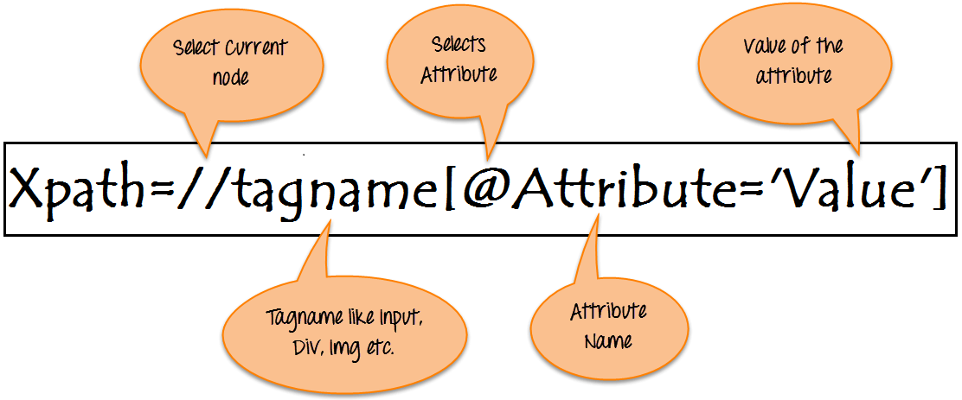
Syntax for XPath:
XPath contains the path of the element situated at the web page. Standard syntax for creating XPath is.
Xpath=//tagname[@attribute='value']
- // : Select current node.
- Tagname: Tagname of the particular node.
- @: Select attribute.
- Attribute: Attribute name of the node.
- Value: Value of the attribute.
To find the element on web pages accurately there are different types of locators:
XPath Locators | Find different elements on web page
ID | To find the element by ID of the element
Classname | To find the element by Classname of the element
Name | To find the element by name of the element
Link text | To find the element by text of the link
XPath | XPath required for finding the dynamic element and traverse between various elements of the web page
CSS path | CSS path also locates elements having no name, class or ID.

Types of X-path
There are two types of XPath:
1) Absolute XPath .
2) Relative XPath .
Absolute XPath :
It is the direct way to find the element, but the disadvantage of the absolute XPath is that if there are any changes made in the path of the element then that XPath gets failed.
The key characteristic of XPath is that it begins with the single forward slash(/) ,which means you can select the element from the root node.
Below is the example of an absolute xpath expression of the element shown in the below screen.
Absolute xpath:
html/body/div[1]/section/div[1]/div/div/div/div[1]/div/div/div/div/div[3]/div[1]/div/h4[1]/b
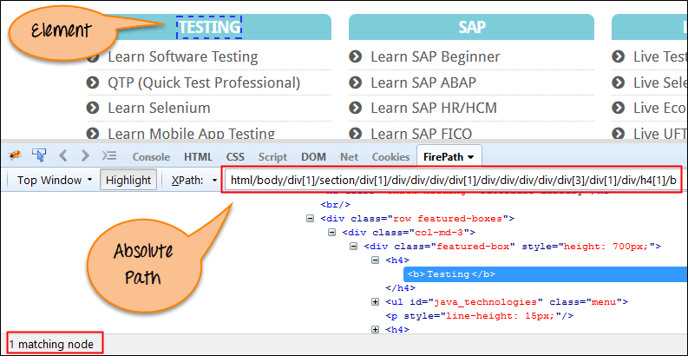
Relative xpath:
For Relative Xpath the path starts from the middle of the HTML DOM structure. It starts with the double forward slash (//), which means it can search the element anywhere at the webpage.
You can start from the middle of the HTML DOM structure and no need to write long xpath.
Below is the example of a relative XPath expression of the same element shown in the below screen. This is the common format used to find element through a relative XPath.
Relative xpath: //*[@class='featured-box']//*[text()='Testing']
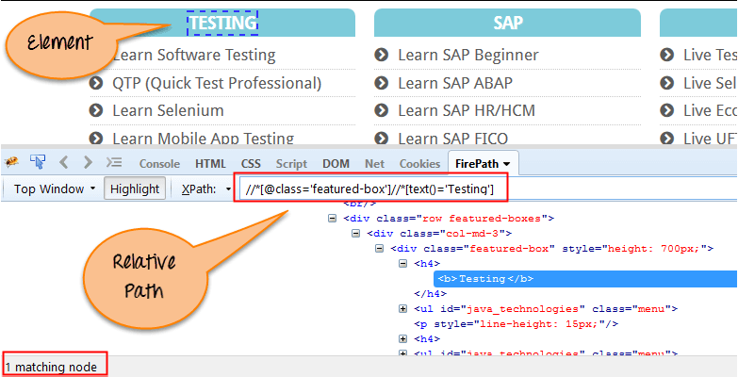
What are XPath axes.
XPath axes search different nodes in XML document from current context node. XPath Axes are the methods used to find dynamic elements, which otherwise not possible by normal XPath method having no ID , Classname, Name, etc.
Axes methods are used to find those elements, which dynamically change on refresh or any other operations. There are few axes methods commonly used in Selenium Webdriver like child, parent, ancestor, sibling, preceding, self, etc.

Using XPath Handling complex & Dynamic elements in Selenium

1) Basic XPath:
XPath expression select nodes or list of nodes on the basis of attributes like ID , Name, Classname, etc. from the XML document as illustrated below.
Xpath=//input[@name='uid']
Here is a link to access the page http://demo.guru99.com/v1/
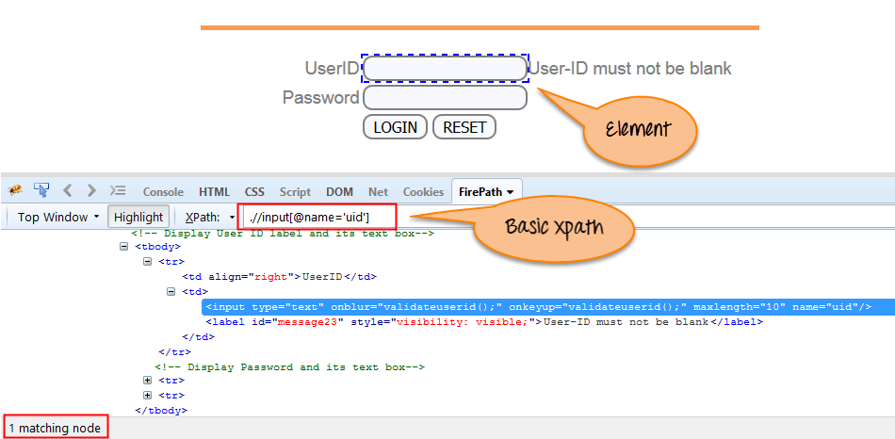
Some more basic xpath expressions:
Xpath=//input[@type='text']
Xpath= //label[@id='message23']
Xpath= //input[@value='RESET']
Xpath=//*[@class='barone']
Xpath=//a[@href='http://demo.guru99.com/']
Xpath= //img[@src='//cdn.guru99.com/images/home/java.png']
2) Contains() : Contains() is a method used in XPath expression. It is used when the value of any attribute changes dynamically, for example, login information.
The contain feature has an ability to find the element with partial text as shown in below example.
In this example, we tried to identify the element by just using partial text value of the attribute. In the below XPath expression partial value 'sub' is used in place of submit button. It can be observed that the element is found successfully.
Complete value of 'Type' is 'submit' but using only partial value 'sub'.
Xpath=//*[contains(@type,'sub')]
Complete value of 'name' is 'btnLogin' but using only partial value 'btn'.
Xpath=.//*[contains(@name,'btn')]
In the above expression, we have taken the 'name' as an attribute and 'btn' as an partial value as shown in the below screenshot. This will find 2 elements (LOGIN & RESET) as their 'name' attribute begins with 'btn'.
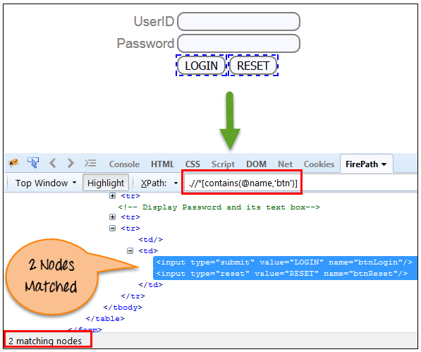
Similarly, in the below expression, we have taken the 'id' as an attribute and 'message' as a partial value. This will find 2 elements ('User-ID must not be blank' & 'Password must not be blank') as its 'name' attribute begins with 'message'.
Xpath=//*[contains(@id,'message')]
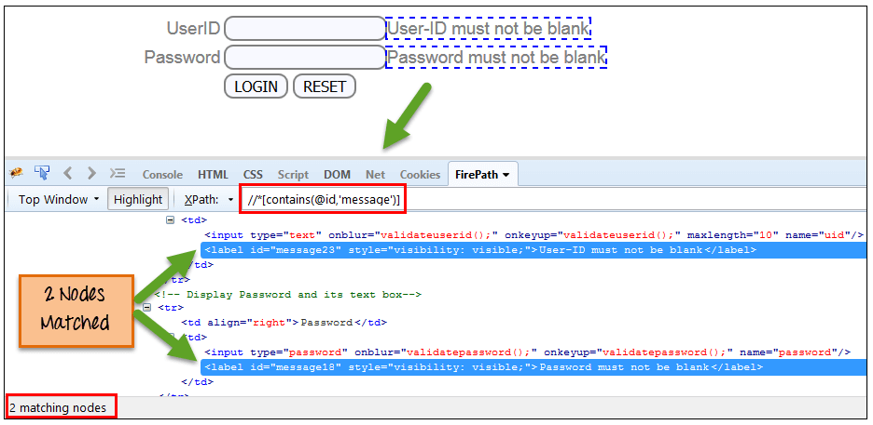
In the below expression, we have taken the "text" of the link as an attribute and 'here' as a partial value as shown in the below screenshot. This will find the link ('here') as it displays the text 'here'.
Xpath=//*[contains(text(),'here')]
Xpath=//*[contains(@href,'guru99.com')]
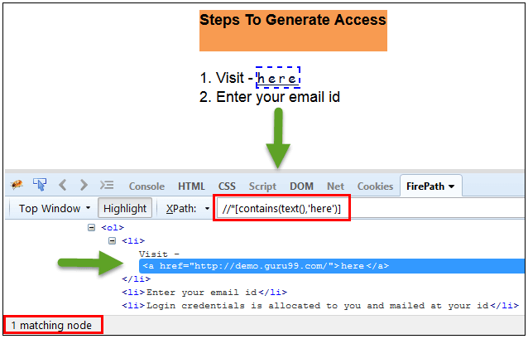

3) Using OR & AND:
In OR expression, two conditions are used, whether 1st condition OR 2nd condition should be true. It is also applicable if any one condition is true or maybe both. Means any one condition should be true to find the element.
In the below XPath expression, it identifies the elements whose single or both conditions are true.
Xpath=//*[@type='submit' OR @name='btnReset']
Highlighting both elements as "LOGIN " element having attribute 'type' and "RESET" element having attribute 'name'.
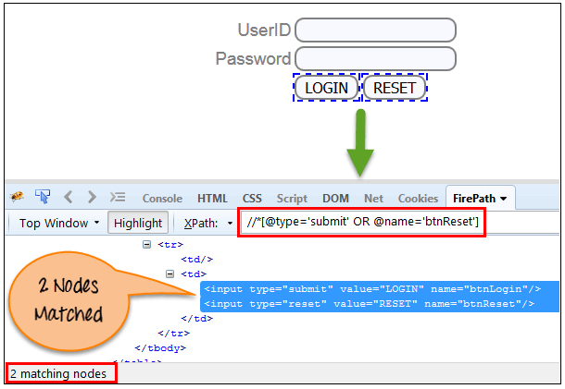
In AND expression, two conditions are used, both conditions should be true to find the element. It fails to find element if any one condition is false.
Xpath=//input[@type='submit' AND @name='btnLogin']
In below expression, highlighting 'LOGIN' element as it having both attribute 'type' and 'name'.
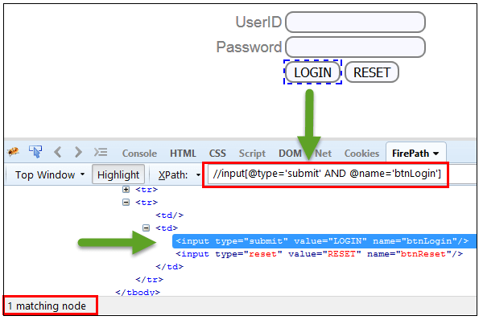
4) Start-with function: Start-with function finds the element whose attribute value changes on refresh or any operation on the webpage. In this expression, match the starting text of the attribute is used to find the element whose attribute changes dynamically. You can also find the element whose attribute value is static (not changes).
For example -: Suppose the ID of particular element changes dynamically like:
Id=" message12"
Id=" message345"
Id=" message8769"
and so on.. but the initial text is same. In this case, we use Start-with expression.
In the below expression, there are two elements with an id starting "message"(i.e., 'User-ID must not be blank' & 'Password must not be blank'). In below example, XPath finds those element whose 'ID' starting with 'message'.
Xpath=//label[starts-with(@id,'message')]
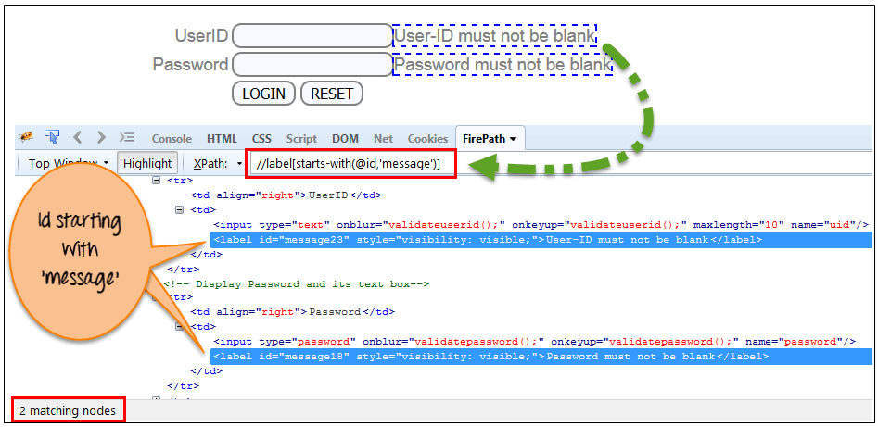
5) Text(): In this expression, with text function, we find the element with exact text match as shown below. In our case, we find the element with text "UserID".
Xpath=//td[text()='UserID']
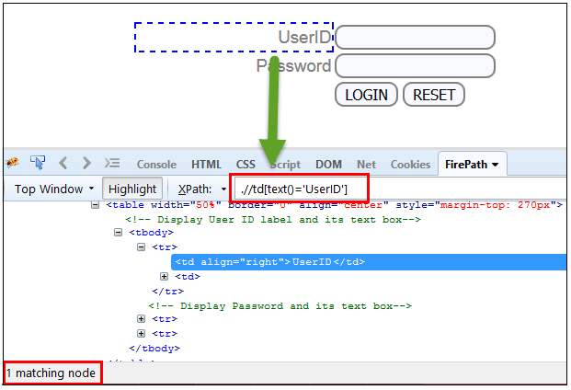
6) XPath axes methods: These XPath axes methods are used to find the complex or dynamic elements. Below we will see some of these methods.
For illustrating these XPath axes method, we will use the Guru99 bank demo site.
a) Following: Selects all elements in the document of the current node( ) [ UserID input box is the current node] as shown in the below screen.
Xpath=//*[@type='text']//following::input
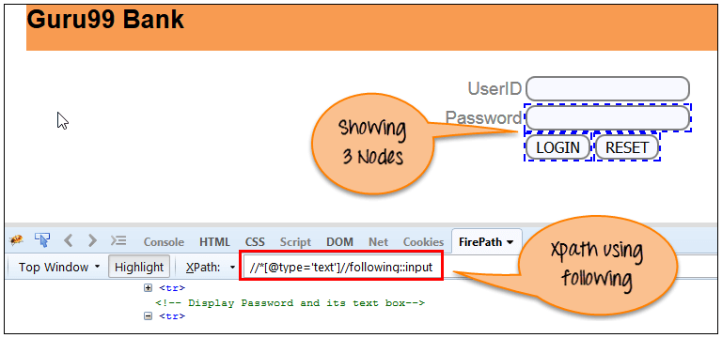
There are 3 "input" nodes matching by using "following" axis- password, login and reset button. If you want to focus on any particular element then you can use the below XPath method:
Xpath=//*[@type='text']//following::input[1]
You can change the XPath according to the requirement by putting [1],[2]…………and so on.
With the input as '1', the below screen shot finds the particular node that is 'Password' input box element.
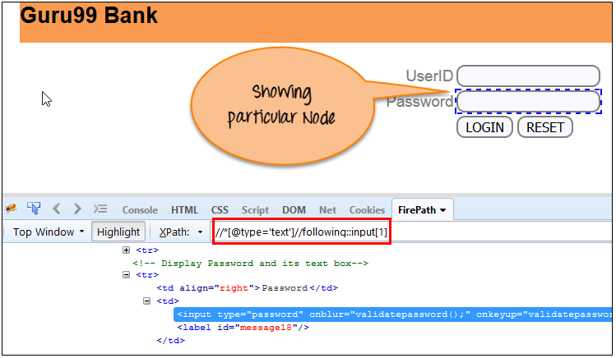
b) Ancestor: The ancestor axis selects all ancestors element (grandparent, parent, etc.) of the current node as shown in the below screen.
In the below expression, we are finding ancestors element of the current node("ENTERPRISE TESTING" node).
Xpath=//*[text()='Enterprise Testing']//ancestor::div
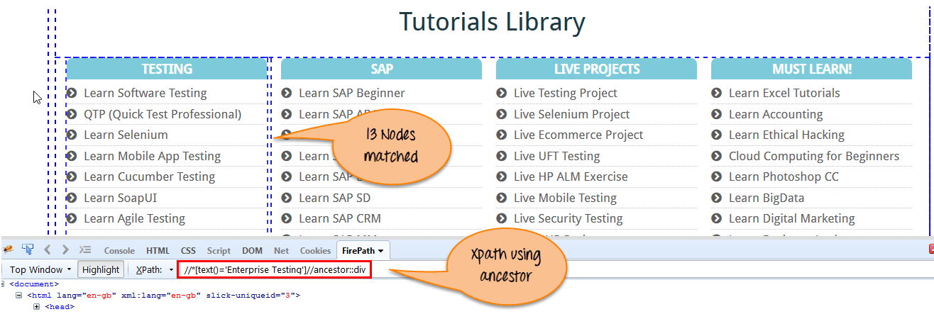
There are 13 "div" nodes matching by using "ancestor" axis. If you want to focus on any particular element then you can use the below XPath, where you change the number 1, 2 as per your requirement:
Xpath=//*[text()='Enterprise Testing']//ancestor::div[1]
You can change the XPath according to the requirement by putting [1], [2]…………and so on.
c) Child : Selects all children elements of the current node (Java) as shown in the below screen.
Xpath=//*[@id='java_technologies']/child::li
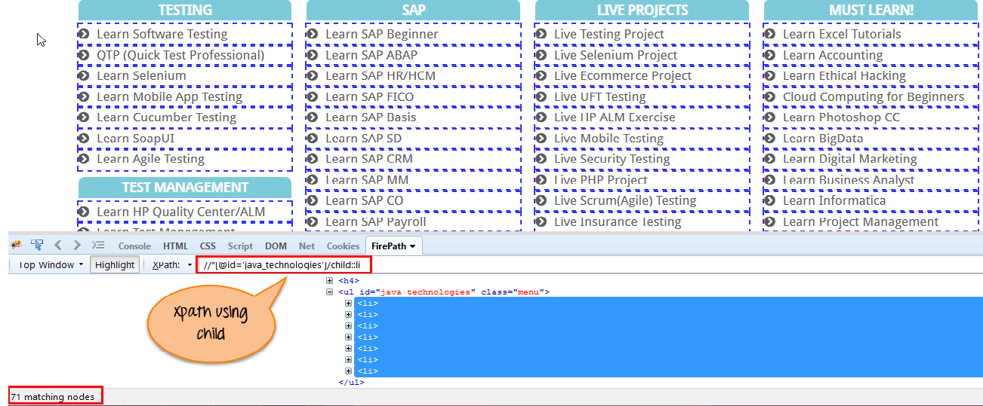
There are 71 "li" nodes matching by using "child" axis. If you want to focus on any particular element then you can use the below xpath:
Xpath=//*[@id='java_technologies']/child::li[1]
You can change the xpath according to the requirement by putting [1],[2]…………and so on.
d) Preceding: Select all nodes that come before the current node as shown in the below screen.
In the below expression, it identifies all the input elements before "LOGIN" button that is Userid and password input element.
Xpath=//*[@type='submit']//preceding::input
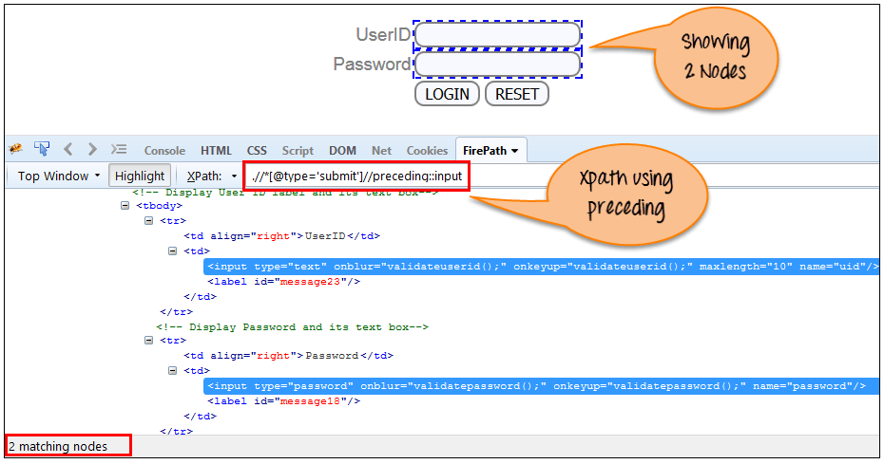
There are 2 "input" nodes matching by using "preceding" axis. If you want to focus on any particular element then you can use the below XPath:
Xpath=//*[@type='submit']//preceding::input[1]
You can change the xpath according to the requirement by putting [1],[2]…………and so on.
e) Following-sibling: Select the following siblings of the context node. Siblings are at the same level of the current node as shown in the below screen. It will find the element after the current node.
xpath=//*[@type='submit']//following-sibling::input
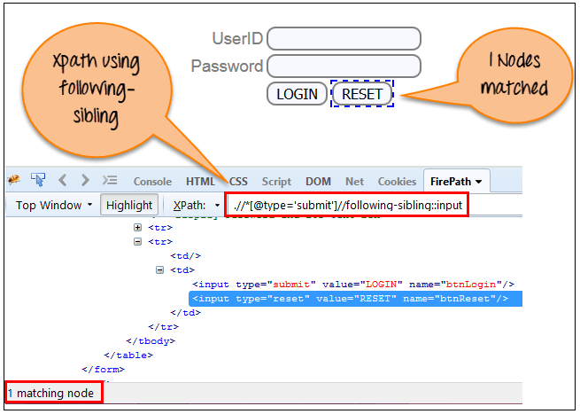
One input nodes matching by using "following-sibling" axis.
f) Parent: Selects the parent of the current node as shown in the below screen.
Xpath=//*[@id='rt-feature']//parent::div
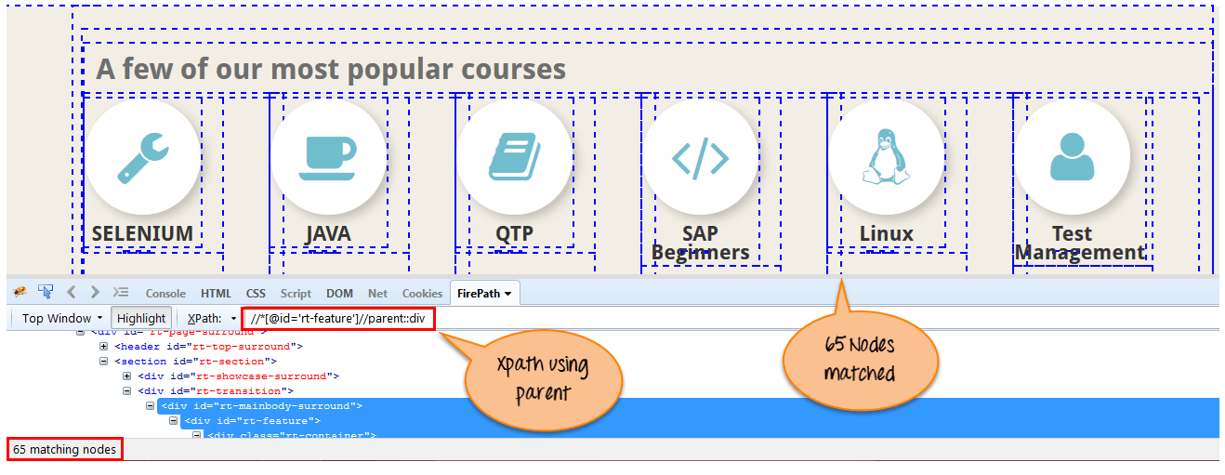
There are 65 "div" nodes matching by using "parent" axis. If you want to focus on any particular element then you can use the below XPath:
Xpath=//*[@id='rt-feature']//parent::div[1]
You can change the XPath according to the requirement by putting [1],[2]…………and so on.
g) Self: Selects the current node or 'self' means it indicates the node itself as shown in the below screen.
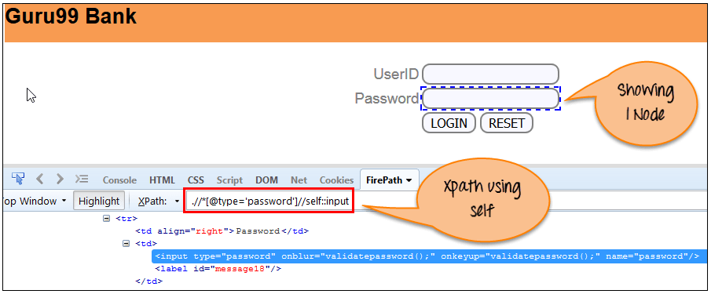
One node matching by using "self " axis. It always finds only one node as it represents self-element.
Xpath =//*[@type='password']//self::input
h) Descendant: Selects the descendants of the current node as shown in the below screen.
In the below expression, it identifies all the element descendants to current element ( 'Main body surround' frame element) which means down under the node (child node , grandchild node, etc.).
Xpath=//*[@id='rt-feature']//descendant::a
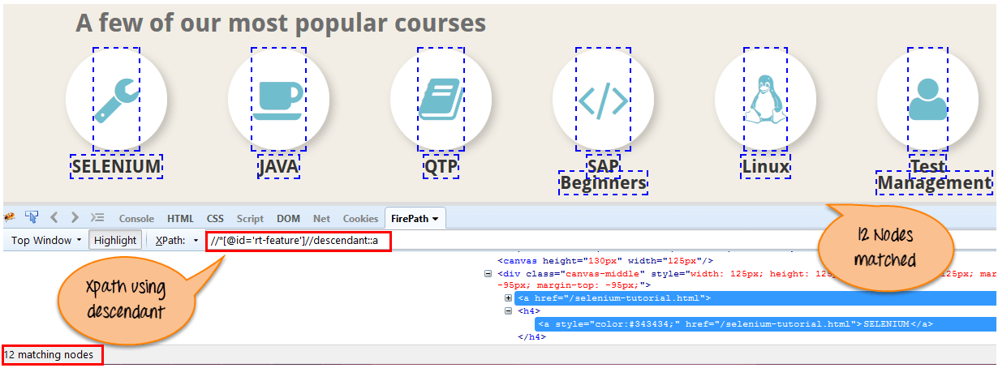
There are 12 "link" nodes matching by using "descendant" axis. If you want to focus on any particular element then you can use the below XPath:
Xpath=//*[@id='rt-feature']//descendant::a[1]
You can change the XPath according to the requirement by putting [1],[2]…………and so on.
Summary:
XPath is required to find an element on the web page as to do an operation on that particular element.
- There are two types of XPath:
  - Absolute XPath
  - Relative XPath
- XPath Axes are the methods used to find dynamic elements, which otherwise not possible to find by normal XPath method
- XPath expression select nodes or list of nodes on the basis of attributes like ID , Name, Classname, etc. from the XML document .

ID and XPath:
import org.openqa.selenium.By;
import org.openqa.selenium.WebDriver;
import org.openqa.selenium.firefox.FirefoxDriver;

public class IdXPATHDemo {

public static void main(String[] args) {
WebDriver driver;
driver = new FirefoxDriver();
String baseURL = "http://www.google.com";
driver.manage().window().maximize();
driver.get(baseURL);

driver.findElement(By.id("lst-ib")).sendKeys("letskodeit");
driver.findElement(By.xpath("//*[@id='sblsbb']/button")).click();
}

}

Interview questions:

Name:
package basicweb;

import org.openqa.selenium.By;
import org.openqa.selenium.WebDriver;
import org.openqa.selenium.firefox.FirefoxDriver;

public class IdNameDemo {

public static void main(String[] args) {
WebDriver driver;
driver = new FirefoxDriver();
String baseURL = "http://www.google.com";
driver.manage().window().maximize();
driver.get(baseURL);

driver.findElement(By.id("lst-ib")).sendKeys("letskodeit");
driver.findElement(By.name("btnG")).click();
}

}

Link text and Partial link text
<a> tag is used for hyperlinks in HTML. This is why it is known as link.
Selenium WebDriver functionality to find element with link text or partial link text works if the text
is inside <a> tag.
For any other tag, we need to build XPath/CSS. For reference, CSS/XPath is covered in
lectures 63 - 75.
The website used for the demo for next lecture has been uploaded a little bit.
Previously the text of the Menu items used to be inside <a> tag.
After the update, text of the Menu items are inside <span> tag.
The current code will not work because of that. But the most important things is that the concept
stays the same.
You should be able to use the same concept on any website where you can find a link with text
inside it.
You need to look at the DOM and make sure that text is within <a> tag.
Google.com is an example, there is a Gmail link on the right hand side and the text is inside <a>
tag. It may change in the future if google makes an update but I wanted to make sure that you
understand the concept and do not reply on any particular website for practice.
package basicweb;

import org.openqa.selenium.By;
import org.openqa.selenium.WebDriver;
import org.openqa.selenium.firefox.FirefoxDriver;

public class FindByLinkText {

public static void main(String[] args) throws Exception {
WebDriver driver;
driver = new FirefoxDriver();
String baseURL = "http://demostore.x-cart.com/";
driver.manage().window().maximize();
driver.get(baseURL);

driver.findElement(By.linkText("Shipping")).click();
Thread.sleep(2000);

driver.findElement(By.partialLinkText("Contact")).click();

}
}

Class Name:
package basicweb;

import org.openqa.selenium.By;
import org.openqa.selenium.WebDriver;
import org.openqa.selenium.firefox.FirefoxDriver;

public class FindByClassName {

public static void main(String[] args) throws Exception {
WebDriver driver;
driver = new FirefoxDriver();
String baseURL = "http://demostore.x-cart.com/";
driver.manage().window().maximize();
driver.get(baseURL);

driver.findElement(By.className("title")).click();

driver.findElement(By.className("leaf")).click();
}
}
Tag Name:
package basicweb;

import org.openqa.selenium.By;
import org.openqa.selenium.WebDriver;
import org.openqa.selenium.firefox.FirefoxDriver;

public class FindByTagName {

public static void main(String[] args) throws Exception {
WebDriver driver;
driver = new FirefoxDriver();

String baseURL = "http://demostore.x-cart.com/";
driver.manage().window().maximize();
driver.get(baseURL);

driver.findElement(By.tagName("a")).click();

// id - fastest
// name
// classname
// xpath
// linktext
// partial link text
// tagname
// css selector
}
}
CSS:
CSS Selectors Cheat Sheet
Every element does not have an id--‐>static id, unique name, unique link text. For those elements we need to build xpath to find and then perform actions on them.
Whatever we use to find an element, id, name, xpath, css --‐> It should always be unique. It should only find one matching node unless we want to capture a list of elements.
Syntax:
tag[attribute='value']
“#” --‐>Id
“.” --‐>Class
Element Displayed Example Text Box:
input[id=displayed--‐text]
#displayed--‐text
input#displayed--‐text
input[class=displayed--‐class]
.displayed--‐class
input.displayed--‐class
Appending Classes
.class1.class2.class3 --‐> Until we find a unique element
Using wildcards in CSS Selectors:
“^”--‐> Represents the starting text
“$” --‐> Represents the ending text
“*” --‐> Represents the text contained
Syntax:
tag[attribute<special character>=’value’]

Examples:
input[class='inputs'] --‐> Only 1 matching node
input[class^='inputs'] --‐> Two matching nodes
input[class='displayed--‐class'] --‐ No matching nodes
input[class$='class'] --‐> One matching node
input[class*='displayed--‐class'] --‐> One matching node
Finding Children
Fieldset --‐> 10 matching nodes
Fieldset>table
fieldset>#product --‐> One matching node
fieldset>button --‐> One matching node
Fieldset>a
fieldset>input#name
XPATH Cheat Sheet
Every element does not have an id --‐> static id, unique name, unique link text. For those elements we need to build xpath to find and then perform actions on them.
Whatever we use to find an element, id, name, xpath --‐> It should always be unique.
It should only find one matching node unless we want to capture a list of elements.
Difference between single ‘/’ or double ‘//’ Single slash ‘/’ anywhere in xpath signifies to look for the element immediately inside the parent element.
Double slash ‘//’ signifies to look for any child or nested--‐ child element inside the parent element.
Syntax:
//tag[@attribute='value']
Relative xpath using single ‘/’ for Login link
//div[@id='navbar']/div/div/div/ul/li[2]/a
Relative xpath using double ‘//’ for Login link.
//div[@id='navbar']//ul/li[2]/a
Don’t use “*”, always use the tag name. Using Text of the element to build xpath Finding Login link:
//div[@class='homepage--‐hero']//a[text()='Enroll
now']
Using Contains to find the elements:
Syntax:
//tag[contains(attribute,‘value’)]
Finding Login link:
//div[@id='navbar']//a[contains(text(),'Login')]
//div[@id='navbar']//a[contains(@class,'navbar--‐link')
and
contains(@href,'sign_in')]
Using Starts--‐With to find the elements:
Syntax:
//tag[starts--‐with(attribute,
‘value’)]
Finding Login link:
//div[@id='navbar']//a[starts--‐with(@class,'navbar--‐link')]
Parent Syntax:
xpath--‐to--‐some--‐element//parent::<tag>
Preceding Sibling Syntax:
xpath--‐to--‐some--‐element//preceding--‐sibling::<tag>
Following Sibling Syntax:
xpath--‐to--‐some--‐element//following--‐sibling::<tag>

Synchronization:

Selenium WebDriver has borrowed the idea of implicit waits from Watir. This means that we can tell Selenium that we would like it to wait for a certain amount of time before throwing an exception that it cannot find the element on the page. We should note that implicit waits will be in place for the entire time the browser is open. This means that any search for elements on the page could take the time the implicit wait is set for.
1  2  3  4  5  6  7 | WebDriver driver = new FirefoxDriver();  driver.manage().timeouts().implicitlyWait(10, TimeUnit.SECONDS);  driver.get("http://url_that_delays_loading");  WebElement myDynamicElement = driver.findElement(By.id("myDynamicElement"));

Fluent Wait
Each FluentWait instance defines the maximum amount of time to wait for a condition, as well as the frequency with which to check the condition. Furthermore, the user may configure the wait to ignore specific types of exceptions whilst waiting, such as NoSuchElementExceptions when searching for an element on the page.

1  2  3  4  5  6  7  8  9  10  11  12  13  14  15  16  17  18  19  20  21 | // Waiting 30 seconds for an element to be present on the page, checking  // for its presence once every 5 seconds.  Wait wait = new FluentWait(driver)  .withTimeout(30, SECONDS)  .pollingEvery(5, SECONDS)  .ignoring(NoSuchElementException.class);  WebElement foo = wait.until(new Function() {  public WebElement apply(WebDriver driver) {  return driver.findElement(By.id("foo"));  }  });

Explicit Wait
It is more extendible in the means that you can set it up to wait for any condition you might like. Usually, you can use some of the prebuilt ExpectedConditions to wait for elements to become clickable, visible, invisible, etc.

1  2  3 | WebDriverWait wait = new WebDriverWait(driver, 10);  WebElement element = wait.until(ExpectedConditions.elementToBeClickable(By.id("someid")));

Difference Between Implicit, Explicit and Fluent Wait
Implicit Wait: During Implicit wait if the Web Driver cannot find it immediately because of its availability, it will keep polling (around 250 milli seconds) the DOM to get the element. If the element is not available within the specified Time an NoSuchElementException will be raised. The default setting is zero. Once we set a time, the Web Driver waits for the period of the WebDriver object instance.
Explicit Wait: There can be instance when a particular element takes more than a minute to load. In that case you definitely not like to set a huge time to Implicit wait, as if you do this your browser will going to wait for the same time for every element.
To avoid that situation you can simply put a separate time on the required element only. By following this your browser implicit wait time would be short for every element and it would be large for specific element.
Fluent Wait: Let’s say you have an element which sometime appears in just 1 second and some time it takes minutes to appear. In that case it is better to use fluent wait, as this will try to find element again and again until it find it or until the final timer runs out.
Solutions: We always get confuse when it comes to using Wait commands, to better understand it we need to remember that there is a difference between several scenarios:
An element not being present at all in the DOM.
An element being present in the DOM but not visible.
An element being present in the DOM but not enabled. (i.e. clickable)
There are pages which get displayed with the JavaScript, the elements are already present in the browser DOM, but are not visible. The implicit wait only waits for an element to appear in the DOM, so it returns immediately, but when you try to interact with the element you get a NoSuchElementException. You could test this hypothesis by writing a helper method that explicit wait for an element to be visible or clickable.

1  2  3  4  5  6  7  8  9  10  11 | public WebElement getWhenVisible(By locator, int timeout) {  WebElement element = null;  WebDriverWait wait = new WebDriverWait(driver, timeout);  element = wait.until(ExpectedConditions.visibilityOfElementLocated(locator));  return element;  }

1  2  3  4  5  6  7  8  9  10  11 | public void clickWhenReady(By locator, int timeout) {  WebElement element = null;  WebDriverWait wait = new WebDriverWait(driver, timeout);  element = wait.until(ExpectedConditions.elementToBeClickable(locator));  element.click();  }

Junit:
- @BeforeClass – Run once before any of the test methods in the class, public static void
- @AfterClass – Run once after all the tests in the class have been run, public static void
- @Before – Run before @Test, public void
- @After – Run after @Test, public void
- @Test – This is the test method to run, public void

Selenium Test:
package basicweb;

import java.util.concurrent.TimeUnit;

import org.junit.After;
import org.junit.Before;
import org.junit.Test;
import org.openqa.selenium.By;
import org.openqa.selenium.WebDriver;
import org.openqa.selenium.firefox.FirefoxDriver;

public class SeleniumTest {
private WebDriver driver;
private String baseUrl;

@Before
public void setUp() throws Exception {
driver = new FirefoxDriver();
baseUrl = "http://www.letskodeit.com/";
driver.manage().timeouts().implicitlyWait(30, TimeUnit.SECONDS);
driver.manage().window().maximize();
}

@Test
public void testSelenium() throws Exception {
driver.get(baseUrl + "/");
driver.findElement(By.id("i90scv3glabel")).click();
driver.findElement(By.linkText("Practice")).click();
}

@After
public void tearDown() throws Exception {
Thread.sleep(3000);
// driver.quit();
}
}

Basic actions:
package basicweb;

import java.util.concurrent.TimeUnit;

import org.junit.After;
import org.junit.Before;
import org.junit.Test;
import org.openqa.selenium.By;
import org.openqa.selenium.WebDriver;
import org.openqa.selenium.firefox.FirefoxDriver;

public class BasicActions {
WebDriver driver;
String baseUrl;

@Before
public void setUp() throws Exception {
driver = new FirefoxDriver();
baseUrl = "http://letskodeit.teachable.com/";
driver.manage().timeouts().implicitlyWait(10, TimeUnit.SECONDS);
driver.manage().window().maximize();
}

@Test
public void test() {
driver.get(baseUrl);
driver.findElement(By.xpath("//div[@id='navbar']//a[@href='/sign_in']")).click();
System.out.println("Clicked on login");
driver.findElement(By.id("user_email")).sendKeys("test@email.com");
System.out.println("Sending keys to username field");
driver.findElement(By.id("user_password")).sendKeys("test");
System.out.println("Sending keys to password field");
driver.findElement(By.id("user_email")).clear();
System.out.println("Clearing the username field");
}

@After
public void tearDown() throws Exception {
// driver.quit();
}
}
Navigation:
package basicweb;

import java.util.concurrent.TimeUnit;

import org.junit.After;
import org.junit.Before;
import org.junit.Test;
import org.openqa.selenium.WebDriver;
import org.openqa.selenium.firefox.FirefoxDriver;

public class NavigatingBetweenPages {
WebDriver driver;
String baseUrl;

@Before
public void setUp() throws Exception {
driver = new FirefoxDriver();
baseUrl = "http://letskodeit.teachable.com/";
driver.manage().timeouts().implicitlyWait(10, TimeUnit.SECONDS);
driver.manage().window().maximize();
}

@Test
public void test() throws InterruptedException {
driver.get(baseUrl);
String title = driver.getTitle();
System.out.println("Title of the page is: " + title);

String currentUrl = driver.getCurrentUrl();
System.out.println("Current URL is: " + currentUrl);

String urlToNavigate = "https://sso.teachable.com/secure/42299/users/sign_in?reset_purchase_session=1";
driver.navigate().to(urlToNavigate);
System.out.println("Navigating To Login");
currentUrl = driver.getCurrentUrl();
System.out.println("Current URL is: " + currentUrl);

Thread.sleep(2000);

driver.navigate().back();
System.out.println("Navigate Back");
currentUrl = driver.getCurrentUrl();
System.out.println("Current URL is: " + currentUrl);

Thread.sleep(2000);

driver.navigate().forward();
System.out.println("Navigate Forward");
currentUrl = driver.getCurrentUrl();
System.out.println("Current URL is: " + currentUrl);

Thread.sleep(2000);

driver.navigate().back();
System.out.println("Navigate Back");
currentUrl = driver.getCurrentUrl();
System.out.println("Current URL is: " + currentUrl);

driver.navigate().refresh();
System.out.println("Navigate Refresh");
driver.get(currentUrl);
System.out.println("Navigate Refresh");

String pageSource = driver.getPageSource();
System.out.println(pageSource);
}

@After
public void tearDown() throws Exception {
// driver.quit();
}
}
Element State:
package workingwithelements;

import java.util.concurrent.TimeUnit;

import org.junit.After;
import org.junit.Before;
import org.junit.Test;
import org.openqa.selenium.By;
import org.openqa.selenium.WebDriver;
import org.openqa.selenium.WebElement;
import org.openqa.selenium.firefox.FirefoxDriver;

public class ElementState {
WebDriver driver;
String baseUrl;

@Before
public void setUp() throws Exception {
driver = new FirefoxDriver();
baseUrl = "https://www.google.com";
driver.manage().timeouts().implicitlyWait(10, TimeUnit.SECONDS);
driver.manage().window().maximize();
driver.get(baseUrl);
}

@Test
public void test() {
WebElement e1 = driver.findElement(By.id("gs_htif0"));
System.out.println("E1 is Enabled? " + e1.isEnabled());

WebElement e2 = driver.findElement(By.id("gs_taif0"));
System.out.println("E2 is Enabled? " + e2.isEnabled());

WebElement e3 = driver.findElement(By.id("lst-ib"));
System.out.println("E3 is Enabled? " + e3.isEnabled());

e3.sendKeys("letskodeit");
}

@After
public void tearDown() throws Exception {
Thread.sleep(2000);
driver.quit();
}
}
Radio Buttons and checkboxes:
package workingwithelements;

import java.util.concurrent.TimeUnit;

import org.junit.After;
import org.junit.Before;
import org.junit.Test;
import org.openqa.selenium.By;
import org.openqa.selenium.WebDriver;
import org.openqa.selenium.WebElement;
import org.openqa.selenium.firefox.FirefoxDriver;

public class RadioButtonsAndCheckBoxes {
WebDriver driver;
String baseUrl;

@Before
public void setUp() throws Exception {
driver = new FirefoxDriver();
baseUrl = "http://letskodeit.teachable.com/pages/practice";
driver.manage().timeouts().implicitlyWait(10, TimeUnit.SECONDS);
driver.manage().window().maximize();
driver.get(baseUrl);
}

@Test
public void test() throws InterruptedException {
WebElement bmwRadioBtn = driver.findElement(By.id("bmwradio"));
bmwRadioBtn.click();

Thread.sleep(2000);
WebElement benzRadioBtn = driver.findElement(By.id("benzradio"));
benzRadioBtn.click();

Thread.sleep(2000);
WebElement bmwCheckBox = driver.findElement(By.id("bmwcheck"));
bmwCheckBox.click();

Thread.sleep(2000);
WebElement benzCheckBox = driver.findElement(By.id("benzcheck"));
benzCheckBox.click();

System.out.println("BMW Radio Button is selected? " + bmwRadioBtn.isSelected());
System.out.println("Benz Radio Button is selected? " + benzRadioBtn.isSelected());
System.out.println("BMW Checkbox is selected? " + bmwCheckBox.isSelected());
System.out.println("Benz Checkbox is selected? " + benzCheckBox.isSelected());
}

@After
public void tearDown() throws Exception {
Thread.sleep(3000);
//driver.quit();
}
}
WebElement List:
package workingwithelements;

import java.util.List;
import java.util.concurrent.TimeUnit;
import org.junit.After;
import org.junit.Before;
import org.junit.Test;
import org.openqa.selenium.By;
import org.openqa.selenium.WebDriver;
import org.openqa.selenium.WebElement;
import org.openqa.selenium.firefox.FirefoxDriver;

public class WorkingWithElementsList {
private WebDriver driver;
private String baseUrl;

@Before
public void setUp() throws Exception {
driver = new FirefoxDriver();
baseUrl = "http://letskodeit.teachable.com/pages/practice";

// Maximize the browser's window
driver.manage().window().maximize();
driver.manage().timeouts().implicitlyWait(10, TimeUnit.SECONDS);
driver.get(baseUrl);
}

@Test
public void testListOfElements() throws Exception {
boolean isChecked = false;
List<WebElement> radioButtons = driver.findElements(
By.xpath("//input[contains(@type,'radio') and contains(@name,'cars')]"));
int size = radioButtons.size();
System.out.println("Size of the list: " + size);
for (int i=0; i<size; i++) {
isChecked = radioButtons.get(i).isSelected();

if (!isChecked) {
radioButtons.get(i).click();
Thread.sleep(2000);
}
}
}

@After
public void tearDown() throws Exception {
Thread.sleep(2000);
driver.quit();
}

}
Dropdown list:
package workingwithelements;

import java.util.concurrent.TimeUnit;
import java.util.*;
import org.junit.After;
import org.junit.Before;
import org.junit.Test;
import org.openqa.selenium.By;
import org.openqa.selenium.WebDriver;
import org.openqa.selenium.WebElement;
import org.openqa.selenium.firefox.FirefoxDriver;
import org.openqa.selenium.support.ui.Select;

public class DropdownSelect {
private WebDriver driver;
private String baseUrl;

@Before
public void setUp() throws Exception {
System.setProperty("webdriver.gecko.driver",
"/Users/atomar/Documents/workspace_personal/libs/geckodriver");
driver = new FirefoxDriver();
baseUrl = "https://letskodeit.teachable.com/p/practice";

// Maximize the browser's window
driver.manage().window().maximize();
driver.manage().timeouts().implicitlyWait(10, TimeUnit.SECONDS);
}

@Test
public void testDropdown() throws Exception {
driver.get(baseUrl);
WebElement element = driver.findElement(By.id("carselect"));
Select sel = new Select(element);

Thread.sleep(2000);
System.out.println("Select Benz by value");
sel.selectByValue("benz");

Thread.sleep(2000);
System.out.println("Select Honda by index");
sel.selectByIndex(2);

Thread.sleep(2000);
System.out.println("Select BMW by visible text");
sel.selectByVisibleText("BMW");

Thread.sleep(2000);
System.out.println("Print the list of all options");
List<WebElement> options = sel.getOptions();
int size = options.size();

for (int i=0; i<size; i++) {
String optionName = options.get(i).getText();
System.out.println(optionName);
}
}

@After
public void tearDown() throws Exception {
Thread.sleep(2000);
driver.quit();
}
}

MultiSelect
package workingwithelements;

import java.util.concurrent.TimeUnit;
import java.util.*;

import org.junit.After;
import org.junit.Before;
import org.junit.Test;
import org.openqa.selenium.By;
import org.openqa.selenium.WebDriver;
import org.openqa.selenium.WebElement;
import org.openqa.selenium.firefox.FirefoxDriver;
import org.openqa.selenium.support.ui.Select;

public class MultipleSelect {
private WebDriver driver;
private String baseUrl;

@Before
public void setUp() throws Exception {
System.setProperty("webdriver.gecko.driver",
"/Users/atomar/Documents/workspace_personal/libs/geckodriver");
driver = new FirefoxDriver();
baseUrl = "https://letskodeit.teachable.com/p/practice";

// Maximize the browser's window
driver.manage().window().maximize();
driver.manage().timeouts().implicitlyWait(10, TimeUnit.SECONDS);
}

@Test
public void testMultiSelect() throws Exception {
driver.get(baseUrl);
WebElement element = driver.findElement(By.id("multiple-select-example"));
Select sel = new Select(element);

Thread.sleep(2000);
System.out.println("Select orange by value");
sel.selectByValue("orange");

Thread.sleep(2000);
System.out.println("De-select orange by value");
sel.deselectByValue("orange");

Thread.sleep(2000);
System.out.println("Select peach by index");
sel.selectByIndex(2);

Thread.sleep(2000);
System.out.println("Select Apple by visible text");
sel.selectByVisibleText("Apple");

Thread.sleep(2000);
System.out.println("Print all selected options");
List<WebElement> selectedOptions = sel.getAllSelectedOptions();
for (WebElement option : selectedOptions) {
System.out.println(option.getText());
}

Thread.sleep(2000);
System.out.println("De-select all selected options");
sel.deselectAll();
}

@After
public void tearDown() throws Exception {
Thread.sleep(2000);
driver.quit();
}
}

Hidden elements:
package workingwithelements;

import java.util.concurrent.TimeUnit;

import org.junit.After;
import org.junit.Before;
import org.junit.Test;
import org.openqa.selenium.By;
import org.openqa.selenium.JavascriptExecutor;
import org.openqa.selenium.WebDriver;
import org.openqa.selenium.WebElement;
import org.openqa.selenium.firefox.FirefoxDriver;

public class ElementDisplayed {
WebDriver driver;
// Adding code for JS
private JavascriptExecutor js;
String baseUrl1;
String baseUrl2;

@Before
public void setUp() throws Exception {
driver = new FirefoxDriver();
// Adding code for JS
js = (JavascriptExecutor) driver;
baseUrl1 = "http://letskodeit.teachable.com/pages/practice";
baseUrl2 = "http://www.expedia.com";
driver.manage().timeouts().implicitlyWait(2, TimeUnit.SECONDS);
driver.manage().window().maximize();
}
@Test
public void testLetsKodeIt() throws InterruptedException {
driver.get(baseUrl1);

WebElement textBox = driver.findElement(By.id("displayed-text"));
System.out.println("Text Box Displayed: " + textBox.isDisplayed());

Thread.sleep(3000);

WebElement hideButton = driver.findElement(By.id("hide-textbox"));
hideButton.click();
System.out.println("Clicked on hide button");
System.out.println("Text Box Displayed: " + textBox.isDisplayed());

Thread.sleep(3000);

// Added code to scroll up because the element was hiding behind the top navigation menu
// You will learn about scrolling in future lecture
js.executeScript("window.scrollBy(0, -190);");
WebElement showButton = driver.findElement(By.id("show-textbox"));
showButton.click();
System.out.println("Clicked on show button");
System.out.println("Text Box Displayed: " + textBox.isDisplayed());
}

@Test
public void testExpedia() throws InterruptedException {
driver.get(baseUrl2);

WebElement childDropdown = driver.findElement(By.id("package-1-age-select-1"));
System.out.println("Child Drpdown Displayed: " + childDropdown.isDisplayed());
}

@After
public void tearDown() throws Exception {
Thread.sleep(2000);
driver.quit();
}
}

Get text:
package usefulmethods;

import java.util.concurrent.TimeUnit;

import org.junit.After;
import org.junit.Before;
import org.junit.Test;
import org.openqa.selenium.By;
import org.openqa.selenium.WebDriver;
import org.openqa.selenium.WebElement;
import org.openqa.selenium.firefox.FirefoxDriver;

public class GetTextDemo {

private WebDriver driver;
private String baseUrl;

@Before
public void setUp() throws Exception {
driver = new FirefoxDriver();
baseUrl = "https://letskodeit.teachable.com/pages/practice";

// Maximize the browser's window
driver.manage().window().maximize();
driver.manage().timeouts().implicitlyWait(10, TimeUnit.SECONDS);
}

@Test
public void testGetText() throws Exception {
driver.get(baseUrl);

WebElement buttonElement = driver.findElement(By.id("opentab"));
String elementText = buttonElement.getText();

System.out.println("Text on the element is: " + elementText);
}

@After
public void tearDown() throws Exception {
Thread.sleep(2000);
driver.quit();
}
}
Get Attribute:
package usefulmethods;

import java.util.concurrent.TimeUnit;

import org.junit.After;
import org.junit.Before;
import org.junit.Test;
import org.openqa.selenium.By;
import org.openqa.selenium.WebDriver;
import org.openqa.selenium.WebElement;
import org.openqa.selenium.firefox.FirefoxDriver;

public class GetAttributeDemo {

private WebDriver driver;
private String baseUrl;

@Before
public void setUp() throws Exception {
driver = new FirefoxDriver();
baseUrl = "https://letskodeit.teachable.com/pages/practice";

// Maximize the browser's window
driver.manage().window().maximize();
driver.manage().timeouts().implicitlyWait(10, TimeUnit.SECONDS);
}

@Test
public void testGetText() throws Exception {
driver.get(baseUrl);

WebElement element = driver.findElement(By.id("name"));
String attributeValue = element.getAttribute("type");

System.out.println("Value of attribue is: " + attributeValue);
}

@After
public void tearDown() throws Exception {
Thread.sleep(2000);
driver.quit();
}
}
Generic Method for element identification:
package usefulmethods;

import java.util.List;

import org.openqa.selenium.By;
import org.openqa.selenium.WebDriver;
import org.openqa.selenium.WebElement;

public class GenericMethods {
WebDriver driver;

public GenericMethods(WebDriver driver) {
this.driver = driver;
}

public WebElement getElement(String locator, String type) {
type = type.toLowerCase();
if (type.equals("id")) {
System.out.println("Element found with id: " + locator);
return this.driver.findElement(By.id(locator));
}
else if (type.equals("xpath")) {
System.out.println("Element found with xpath: " + locator);
return this.driver.findElement(By.xpath(locator));
}
else if (type.equals("css")) {
System.out.println("Element found with xpath: " + locator);
return this.driver.findElement(By.cssSelector(locator));
}
else if (type.equals("linktext")) {
System.out.println("Element found with xpath: " + locator);
return this.driver.findElement(By.linkText(locator));
}
else if (type.equals("partiallinktext")) {
System.out.println("Element found with xpath: " + locator);
return this.driver.findElement(By.partialLinkText(locator));
}
else {
System.out.println("Locator type not supported");
return null;
}
}
}
Calling generic Methods:
package usefulmethods;

import java.util.concurrent.TimeUnit;

import org.junit.After;
import org.junit.Before;
import org.junit.Test;
import org.openqa.selenium.By;
import org.openqa.selenium.WebDriver;
import org.openqa.selenium.WebElement;
import org.openqa.selenium.firefox.FirefoxDriver;
import usefulmethods.GenericMethods;

public class GenericMethodsDemo {

private WebDriver driver;
private String baseUrl;
private GenericMethods gm;

@Before
public void setUp() throws Exception {
driver = new FirefoxDriver();
baseUrl = "https://letskodeit.teachable.com/pages/practice";
gm = new GenericMethods(driver);

// Maximize the browser's window
driver.manage().window().maximize();
driver.manage().timeouts().implicitlyWait(10, TimeUnit.SECONDS);
}

@Test
public void testMethod() throws Exception {
driver.get(baseUrl);

WebElement element = gm.getElement("name", "id");
element.sendKeys("test");
}

@After
public void tearDown() throws Exception {
Thread.sleep(2000);
//driver.quit();
}
}

Element list generic method:
package usefulmethods;

import java.util.List;
import java.util.concurrent.TimeUnit;

import org.junit.After;
import org.junit.Before;
import org.junit.Test;
import org.openqa.selenium.By;
import org.openqa.selenium.WebDriver;
import org.openqa.selenium.WebElement;
import org.openqa.selenium.firefox.FirefoxDriver;
import usefulmethods.GenericMethods;

public class ElementListDemo {

private WebDriver driver;
private String baseUrl;
private GenericMethods gm;

@Before
public void setUp() throws Exception {
driver = new FirefoxDriver();
baseUrl = "https://letskodeit.teachable.com/pages/practice";
gm = new GenericMethods(driver);

// Maximize the browser's window
driver.manage().window().maximize();
driver.manage().timeouts().implicitlyWait(10, TimeUnit.SECONDS);
}

@Test
public void testMethod() throws Exception {
driver.get(baseUrl);

List<WebElement> elementList = gm.getElementList("//input[@type='text']", "xpath");

int size = elementList.size();
System.out.println("Size of the element list is: " + size);

}

@After
public void tearDown() throws Exception {
Thread.sleep(2000);
//driver.quit();
}
}
Element list generic Method:
package usefulmethods;

import java.util.List;

import org.openqa.selenium.By;
import org.openqa.selenium.WebDriver;
import org.openqa.selenium.WebElement;

public class GenericMethods {
WebDriver driver;

public GenericMethods(WebDriver driver) {
this.driver = driver;
}

public WebElement getElement(String locator, String type) {
type = type.toLowerCase();
if (type.equals("id")) {
System.out.println("Element found with id: " + locator);
return this.driver.findElement(By.id(locator));
}
else if (type.equals("xpath")) {
System.out.println("Element found with xpath: " + locator);
return this.driver.findElement(By.xpath(locator));
}
else if (type.equals("css")) {
System.out.println("Element found with xpath: " + locator);
return this.driver.findElement(By.cssSelector(locator));
}
else if (type.equals("linktext")) {
System.out.println("Element found with xpath: " + locator);
return this.driver.findElement(By.linkText(locator));
}
else if (type.equals("partiallinktext")) {
System.out.println("Element found with xpath: " + locator);
return this.driver.findElement(By.partialLinkText(locator));
}
else {
System.out.println("Locator type not supported");
return null;
}
}

public List<WebElement> getElementList(String locator, String type) {
type = type.toLowerCase();
if (type.equals("id")) {
System.out.println("Element found with id: " + locator);
return this.driver.findElements(By.id(locator));
}
else if (type.equals("xpath")) {
System.out.println("Element found with xpath: " + locator);
return this.driver.findElements(By.xpath(locator));
}
else if (type.equals("css")) {
System.out.println("Element found with xpath: " + locator);
return this.driver.findElements(By.cssSelector(locator));
}
else if (type.equals("linktext")) {
System.out.println("Element found with xpath: " + locator);
return this.driver.findElements(By.linkText(locator));
}
else if (type.equals("partiallinktext")) {
System.out.println("Element found with xpath: " + locator);
return this.driver.findElements(By.partialLinkText(locator));
}
else {
System.out.println("Locator type not supported");
return null;
}
}

}

GEM for Element visibility:
package usefulmethods;

import java.util.ArrayList;
import java.util.List;

import org.openqa.selenium.By;
import org.openqa.selenium.WebDriver;
import org.openqa.selenium.WebElement;

public class GenericMethods {
WebDriver driver;

public GenericMethods(WebDriver driver) {
this.driver = driver;
}

public WebElement getElement(String locator, String type) {
type = type.toLowerCase();
if (type.equals("id")) {
System.out.println("Element found with id: " + locator);
return this.driver.findElement(By.id(locator));
}
else if (type.equals("name")) {
System.out.println("Element found with name: " + locator);
return this.driver.findElement(By.name(locator));
}
else if (type.equals("xpath")) {
System.out.println("Element found with xpath: " + locator);
return this.driver.findElement(By.xpath(locator));
}
else if (type.equals("css")) {
System.out.println("Element found with css: " + locator);
return this.driver.findElement(By.cssSelector(locator));
}
else if (type.equals("classname")) {
System.out.println("Element found with classname: " + locator);
return this.driver.findElement(By.className(locator));
}
else if (type.equals("tagname")) {
System.out.println("Element found with tagname: " + locator);
return this.driver.findElement(By.tagName(locator));
}
else if (type.equals("linktext")) {
System.out.println("Element found with link text: " + locator);
return this.driver.findElement(By.linkText(locator));
}
else if (type.equals("partiallinktext")) {
System.out.println("Element found with partial link text: " + locator);
return this.driver.findElement(By.partialLinkText(locator));
}
else {
System.out.println("Locator type not supported");
return null;
}
}

public List<WebElement> getElementList(String locator, String type) {
type = type.toLowerCase();
List<WebElement> elementList = new ArrayList<WebElement>();
if (type.equals("id")) {
elementList = this.driver.findElements(By.id(locator));
}
else if (type.equals("name")) {
elementList = this.driver.findElements(By.name(locator));
}
else if (type.equals("xpath")) {
elementList = this.driver.findElements(By.xpath(locator));
}
else if (type.equals("css")) {
elementList = this.driver.findElements(By.cssSelector(locator));
}
else if (type.equals("classname")) {
elementList = this.driver.findElements(By.className(locator));
}
else if (type.equals("tagname")) {
elementList = this.driver.findElements(By.tagName(locator));
}
else if (type.equals("linktext")) {
elementList = this.driver.findElements(By.linkText(locator));
}
else if (type.equals("partiallinktext")) {
elementList = this.driver.findElements(By.partialLinkText(locator));
}
else {
System.out.println("Locator type not supported");
}
if (elementList.isEmpty()) {
System.out.println("Element not found with " + type +": " + locator);

} else {
System.out.println("Element found with " + type +": " + locator);
}
return elementList;
}

public boolean isElementPresent(String locator, String type) {
List<WebElement> elementList = getElementList(locator, type);

int size = elementList.size();

if (size > 0) {
return true;
}
else {
return false;
}
}
}

GM for element visibility:
package usefulmethods;

import java.util.List;
import java.util.concurrent.TimeUnit;

import org.junit.After;
import org.junit.Before;
import org.junit.Test;
import org.openqa.selenium.By;
import org.openqa.selenium.WebDriver;
import org.openqa.selenium.WebElement;
import org.openqa.selenium.firefox.FirefoxDriver;
import usefulmethods.GenericMethods;

public class isElementPresentDemo {

private WebDriver driver;
private String baseUrl;
private GenericMethods gm;

@Before
public void setUp() throws Exception {
driver = new FirefoxDriver();
baseUrl = "https://letskodeit.teachable.com/pages/practice";
gm = new GenericMethods(driver);

// Maximize the browser's window
driver.manage().window().maximize();
driver.manage().timeouts().implicitlyWait(10, TimeUnit.SECONDS);
}

@Test
public void testMethod() throws Exception {
driver.get(baseUrl);

boolean result1 = gm.isElementPresent("name", "id");
System.out.println("Is Element Present: " + result1);

boolean result2 = gm.isElementPresent("name-not-present", "id");
System.out.println("Is Element Present: " + result2);
}

@After
public void tearDown() throws Exception {
Thread.sleep(2000);
driver.quit();
}
}

Code refactored GM:
package usefulmethods;

import java.util.ArrayList;
import java.util.List;

import org.openqa.selenium.By;
import org.openqa.selenium.WebDriver;
import org.openqa.selenium.WebElement;

public class GenericMethods {
WebDriver driver;

public GenericMethods(WebDriver driver) {
this.driver = driver;
}

public WebElement getElement(String locator, String type) {
type = type.toLowerCase();
if (type.equals("id")) {
System.out.println("Element found with id: " + locator);
return this.driver.findElement(By.id(locator));
}
else if (type.equals("name")) {
System.out.println("Element found with name: " + locator);
return this.driver.findElement(By.name(locator));
}
else if (type.equals("xpath")) {
System.out.println("Element found with xpath: " + locator);
return this.driver.findElement(By.xpath(locator));
}
else if (type.equals("css")) {
System.out.println("Element found with css: " + locator);
return this.driver.findElement(By.cssSelector(locator));
}
else if (type.equals("classname")) {
System.out.println("Element found with classname: " + locator);
return this.driver.findElement(By.className(locator));
}
else if (type.equals("tagname")) {
System.out.println("Element found with tagname: " + locator);
return this.driver.findElement(By.tagName(locator));
}
else if (type.equals("linktext")) {
System.out.println("Element found with link text: " + locator);
return this.driver.findElement(By.linkText(locator));
}
else if (type.equals("partiallinktext")) {
System.out.println("Element found with partial link text: " + locator);
return this.driver.findElement(By.partialLinkText(locator));
}
else {
System.out.println("Locator type not supported");
return null;
}
}

public List<WebElement> getElementList(String locator, String type) {
type = type.toLowerCase();
List<WebElement> elementList = new ArrayList<WebElement>();
if (type.equals("id")) {
elementList = this.driver.findElements(By.id(locator));
}
else if (type.equals("name")) {
elementList = this.driver.findElements(By.name(locator));
}
else if (type.equals("xpath")) {
elementList = this.driver.findElements(By.xpath(locator));
}
else if (type.equals("css")) {
elementList = this.driver.findElements(By.cssSelector(locator));
}
else if (type.equals("classname")) {
elementList = this.driver.findElements(By.className(locator));
}
else if (type.equals("tagname")) {
elementList = this.driver.findElements(By.tagName(locator));
}
else if (type.equals("linktext")) {
elementList = this.driver.findElements(By.linkText(locator));
}
else if (type.equals("partiallinktext")) {
elementList = this.driver.findElements(By.partialLinkText(locator));
}
else {
System.out.println("Locator type not supported");
}
if (elementList.isEmpty()) {
System.out.println("Element not found with " + type +": " + locator);

} else {
System.out.println("Element found with " + type +": " + locator);
}
return elementList;
}

public boolean isElementPresent(String locator, String type) {
List<WebElement> elementList = getElementList(locator, type);

int size = elementList.size();

if (size > 0) {
return true;
}
else {
return false;
}
}
}
GM for code refactored Element visibility:
package usefulmethods;

import java.util.List;
import java.util.concurrent.TimeUnit;

import org.junit.After;
import org.junit.Before;
import org.junit.Test;
import org.openqa.selenium.By;
import org.openqa.selenium.WebDriver;
import org.openqa.selenium.WebElement;
import org.openqa.selenium.firefox.FirefoxDriver;
import usefulmethods.GenericMethods;

public class isElementPresentDemo {

private WebDriver driver;
private String baseUrl;
private GenericMethods gm;

@Before
public void setUp() throws Exception {
driver = new FirefoxDriver();
baseUrl = "https://letskodeit.teachable.com/pages/practice";
gm = new GenericMethods(driver);

// Maximize the browser's window
driver.manage().window().maximize();
driver.manage().timeouts().implicitlyWait(10, TimeUnit.SECONDS);
}

@Test
public void testMethod() throws Exception {
driver.get(baseUrl);

boolean result1 = gm.isElementPresent("name", "id");
System.out.println("Is Element Present: " + result1);

boolean result2 = gm.isElementPresent("name-not-present", "id");
System.out.println("Is Element Present: " + result2);
}

@After
public void tearDown() throws Exception {
Thread.sleep(2000);
driver.quit();
}
}
Waits:
Implicit Wait:
If elements are not immediately available, an implicit wait tells Web Driver to poll the DOM for a certain amount of time. The default setting is 0. Once set, the implicit wait is set for the duration of the Web Driver object. This means that we can tell Selenium WebDriver that we would like it to wait for a certain amount of time before throwing an exception that it cannot find the element on the page. Explicit Wait:
It is the custom one. It will be used if we want the execution to wait for some time until some condition achieved. An explicit waits is what we can define to wait for a certain condition to occur before proceeding further in the code.
These are the available expected conditions:
alertIsPresent
elementSelectionStateToBe
elementToBeClickable
elementToBeSelected
frameToBeAvailableAndSwitchToIt
invisibilityOfElementLocated
presenceOfElementLocated
textToBePresentInElementLocated
textToBePresentInElementValue
titleContains
titles
visibilityOfElementLocated
All Expected Conditions:
https://seleniumhq.github.io/selenium/docs/api/java/org/openqa/selenium/support/ui/ExpectedConditions.html
Selenium WebDriver Official Link:
http://www.seleniumhq.org/docs/04_webdriver_advanced.jsp
WebDriverWait wait = new WebDriverWait(driver, timeout);
element = wait.until(
ExpectedConditions.elementToBeClickable(locator));

Explicit Wait:
package waittypes;

import org.junit.After;
import org.junit.Before;
import org.junit.Test;
import org.openqa.selenium.By;
import org.openqa.selenium.WebDriver;
import org.openqa.selenium.WebElement;
import org.openqa.selenium.firefox.FirefoxDriver;
import org.openqa.selenium.support.ui.ExpectedConditions;
import org.openqa.selenium.support.ui.WebDriverWait;

public class ExplicitWaitDemo {
private WebDriver driver;
private String baseUrl;

@Before
public void setUp() throws Exception {
driver = new FirefoxDriver();
baseUrl = "https://letskodeit.teachable.com/pages/practice";

// Maximize the browser's window
driver.manage().window().maximize();
}

@Test()
public void test() throws Exception {
driver.get(baseUrl);
WebElement loginLink = driver.findElement(By.linkText("Login"));
loginLink.click();
WebDriverWait wait = new WebDriverWait(driver, 3);
WebElement emailField = wait.until(
ExpectedConditions.visibilityOfElementLocated(By.id("user_email")));
emailField.sendKeys("test");

//driver.findElement(By.id("user_email")).sendKeys("test");
}

@After
public void tearDown() throws Exception {
Thread.sleep(3000);
driver.quit();
}
}
GM for Waits:
package waittypes;

import org.junit.After;
import org.junit.Before;
import org.junit.Test;
import org.openqa.selenium.By;
import org.openqa.selenium.WebDriver;
import org.openqa.selenium.WebElement;
import org.openqa.selenium.firefox.FirefoxDriver;
import org.openqa.selenium.support.ui.ExpectedConditions;
import org.openqa.selenium.support.ui.WebDriverWait;
import utilities.WaitTypes;

public class ExplicitWaitWithUtilityDemo {
private WebDriver driver;
private String baseUrl;
WaitTypes wt;

@Before
public void setUp() throws Exception {
driver = new FirefoxDriver();
baseUrl = "https://letskodeit.teachable.com/pages/practice";
wt = new WaitTypes(driver);

// Maximize the browser's window
driver.manage().window().maximize();
}

@Test()
public void test() throws Exception {
driver.get(baseUrl);
WebElement loginLink = driver.findElement(By.linkText("Login"));
loginLink.click();

WebElement emailField = wt.waitForElement(By.id("user_email"), 3);
emailField.sendKeys("test");

//driver.findElement(By.id("user_email")).sendKeys("test");
}

@After
public void tearDown() throws Exception {
Thread.sleep(3000);
driver.quit();
}
}

Wait types Example:
package utilities;

import org.openqa.selenium.By;
import org.openqa.selenium.WebDriver;
import org.openqa.selenium.WebElement;
import org.openqa.selenium.support.ui.ExpectedConditions;
import org.openqa.selenium.support.ui.WebDriverWait;

public class WaitTypes {
WebDriver driver;

public WaitTypes(WebDriver driver) {
this.driver = driver;
}

public WebElement waitForElement(By locator, int timeout) {
WebElement element = null;
try {
System.out.println("Waiting for max:: " + timeout + " seconds for element to be available");

WebDriverWait wait = new WebDriverWait(driver, 3);
element = wait.until(
ExpectedConditions.visibilityOfElementLocated(locator));
System.out.println("Element appeared on the web page");
} catch(Exception e) {
System.out.println("Element not appeared on the web page");
}
return element;
}
}

NOTE: Explicit wait and implicit wait should not be used together.
Explicit Wait Demo:
package waittypes;

import org.junit.After;
import org.junit.Before;
import org.junit.Test;
import org.openqa.selenium.By;
import org.openqa.selenium.WebDriver;
import org.openqa.selenium.WebElement;
import org.openqa.selenium.firefox.FirefoxDriver;
import org.openqa.selenium.support.ui.ExpectedConditions;
import org.openqa.selenium.support.ui.WebDriverWait;
import utilities.WaitTypes;

public class ExplicitWaitWithUtilityDemo {
private WebDriver driver;
private String baseUrl;
WaitTypes wt;

@Before
public void setUp() throws Exception {
driver = new FirefoxDriver();
baseUrl = "https://letskodeit.teachable.com/pages/practice";
wt = new WaitTypes(driver);

// Maximize the browser's window
driver.manage().window().maximize();
}

@Test()
public void test() throws Exception {
driver.get(baseUrl);
WebElement loginLink = driver.findElement(By.linkText("Login"));
loginLink.click();

WebElement emailField = wt.waitForElement(By.id("user_email"), 3);
emailField.sendKeys("test");

wt.clickWhenReady(By.name("commit"), 3);

//driver.findElement(By.id("user_email")).sendKeys("test");
}

@After
public void tearDown() throws Exception {
Thread.sleep(3000);
driver.quit();
}
}
GM for Explicit wait:
package usefulmethods;

import java.util.ArrayList;
import java.util.List;

import org.openqa.selenium.By;
import org.openqa.selenium.WebDriver;
import org.openqa.selenium.WebElement;
import org.openqa.selenium.support.ui.ExpectedConditions;
import org.openqa.selenium.support.ui.WebDriverWait;

public class GenericMethods {
WebDriver driver;

public GenericMethods(WebDriver driver) {
this.driver = driver;
}

public WebElement getElement(String locator, String type) {
type = type.toLowerCase();
if (type.equals("id")) {
System.out.println("Element found with id: " + locator);
return driver.findElement(By.id(locator));
}
else if (type.equals("name")) {
System.out.println("Element found with name: " + locator);
return driver.findElement(By.name(locator));
}
else if (type.equals("xpath")) {
System.out.println("Element found with xpath: " + locator);
return driver.findElement(By.xpath(locator));
}
else if (type.equals("css")) {
System.out.println("Element found with css: " + locator);
return driver.findElement(By.cssSelector(locator));
}
else if (type.equals("classname")) {
System.out.println("Element found with classname: " + locator);
return driver.findElement(By.className(locator));
}
else if (type.equals("tagname")) {
System.out.println("Element found with tagname: " + locator);
return driver.findElement(By.tagName(locator));
}
else if (type.equals("linktext")) {
System.out.println("Element found with link text: " + locator);
return driver.findElement(By.linkText(locator));
}
else if (type.equals("partiallinktext")) {
System.out.println("Element found with partial link text: " + locator);
return driver.findElement(By.partialLinkText(locator));
}
else {
System.out.println("Locator type not supported");
return null;
}
}

public List<WebElement> getElementList(String locator, String type) {
type = type.toLowerCase();
List<WebElement> elementList = new ArrayList<WebElement>();
if (type.equals("id")) {
elementList = driver.findElements(By.id(locator));
}
else if (type.equals("name")) {
elementList = driver.findElements(By.name(locator));
}
else if (type.equals("xpath")) {
elementList = driver.findElements(By.xpath(locator));
}
else if (type.equals("css")) {
elementList = driver.findElements(By.cssSelector(locator));
}
else if (type.equals("classname")) {
elementList = driver.findElements(By.className(locator));
}
else if (type.equals("tagname")) {
elementList = driver.findElements(By.tagName(locator));
}
else if (type.equals("linktext")) {
elementList = driver.findElements(By.linkText(locator));
}
else if (type.equals("partiallinktext")) {
elementList = driver.findElements(By.partialLinkText(locator));
}
else {
System.out.println("Locator type not supported");
}
if (elementList.isEmpty()) {
System.out.println("Element not found with " + type +": " + locator);

} else {
System.out.println("Element found with " + type +": " + locator);
}
return elementList;
}

public boolean isElementPresent(String locator, String type) {
List<WebElement> elementList = getElementList(locator, type);

int size = elementList.size();

if (size > 0) {
return true;
}
else {
return false;
}
}

public WebElement waitForElement(By locator, int timeout) {
WebElement element = null;
try {
System.out.println("Waiting for max:: " + timeout + " seconds for element to be available");

WebDriverWait wait = new WebDriverWait(driver, 3);
element = wait.until(
ExpectedConditions.visibilityOfElementLocated(locator));
System.out.println("Element appeared on the web page");
} catch(Exception e) {
System.out.println("Element not appeared on the web page");
}
return element;
}

public void clickWhenReady(By locator, int timeout) {
try {
WebElement element = null;
System.out.println("Waiting for max:: " + timeout + " seconds for element to be clickable");

WebDriverWait wait = new WebDriverWait(driver, 3);
element = wait.until(
ExpectedConditions.elementToBeClickable(locator));
element.click();
System.out.println("Element clicked on the web page");
} catch(Exception e) {
System.out.println("Element not appeared on the web page");
}
}

}
Wait types:
package utilities;

import org.openqa.selenium.By;
import org.openqa.selenium.WebDriver;
import org.openqa.selenium.WebElement;
import org.openqa.selenium.support.ui.ExpectedConditions;
import org.openqa.selenium.support.ui.WebDriverWait;

public class WaitTypes {
WebDriver driver;

public WaitTypes(WebDriver driver) {
this.driver = driver;
}

public WebElement waitForElement(By locator, int timeout) {
WebElement element = null;
try {
System.out.println("Waiting for max:: " + timeout + " seconds for element to be available");

WebDriverWait wait = new WebDriverWait(driver, 3);
element = wait.until(
ExpectedConditions.visibilityOfElementLocated(locator));
System.out.println("Element appeared on the web page");
} catch(Exception e) {
System.out.println("Element not appeared on the web page");
}
return element;
}

public void clickWhenReady(By locator, int timeout) {
try {
WebElement element = null;
System.out.println("Waiting for max:: " + timeout + " seconds for element to be clickable");

WebDriverWait wait = new WebDriverWait(driver, 3);
element = wait.until(
ExpectedConditions.elementToBeClickable(locator));
element.click();
System.out.println("Element clicked on the web page");
} catch(Exception e) {
System.out.println("Element not appeared on the web page");
}
}
}
Interview Questions
What are the different types of waits available in Selenium WebDriver With Java Programming Language?
There are 2 types of wait
Implicit Wait
Explicit Wait
What is the difference between implicit wait and explicit wait?
Implicit Wait: If elements are not immediately available, an implicit wait tells Web Driver to poll the DOM for a certain amount of time. The default setting is 0. Once set, the implicit wait is set for the duration of the Web Driver object. This means that we can tell Selenium WebDriver that we would like it to wait for a certain amount of time before throwing an exception that it cannot find the element on the page.

Explicit Wait: It is the custom one. It will be used if we want the execution to wait for some time until some condition achieved. There can be instance when a particular element takes more than a minute to load. In that case you definitely not like to
Set a huge time to Implicit wait, as if you do this your browser will be going to wait for the same time for every element. To avoid that situation, you can simply put a separate time on the required element only. By following this your browser implicit wait time would be
Short for every element and it would be large for specific element.
What are some of the expected conditions?
These are the available expected conditions:
elementToBeClickable
presenceOfElementLocated
titleContains
If you use Implicit Wait of 10 seconds and explicit wait of 20 seconds, how much time Selenium WebDriver will wait before timing out?
http://www.seleniumhq.org/docs/04_webdriver_advanced.jsp
Calendar Selection:
package tutorialselenium;

import java.util.List;
import java.util.concurrent.TimeUnit;

import org.junit.After;
import org.junit.Before;
import org.junit.Test;
import org.openqa.selenium.By;
import org.openqa.selenium.WebDriver;
import org.openqa.selenium.WebElement;
import org.openqa.selenium.firefox.FirefoxDriver;

public class CalendarSelection {
private WebDriver driver;
private String baseUrl;

@Before
public void setUp() throws Exception {
driver = new FirefoxDriver();
baseUrl = "http://www.expedia.com/";

// Maximize the browser's window
driver.manage().window().maximize();
driver.manage().timeouts().implicitlyWait(10, TimeUnit.SECONDS);
}

@Test
public void test1() throws Exception {
driver.get(baseUrl);
// Click flights tab
driver.findElement(By.id("tab-flight-tab")).click();
// Find departing field
WebElement departingField = driver.findElement(By.id("flight-departing"));
// Click departing field
departingField.click();
Thread.sleep(3000);
// Find the date to be selected
WebElement dateToSelect = driver.findElement(By.xpath("//section[@class='cal-month'][position()=1]//a[text()='31']"));
// Click the date
dateToSelect.click();
}

@After
public void tearDown() throws Exception {
Thread.sleep(3000);
driver.quit();
}
}
Calendar Selection:
package tutorialselenium;

import java.util.List;
import java.util.concurrent.TimeUnit;

import org.junit.After;
import org.junit.Before;
import org.junit.Test;
import org.openqa.selenium.By;
import org.openqa.selenium.WebDriver;
import org.openqa.selenium.WebElement;
import org.openqa.selenium.firefox.FirefoxDriver;

public class CalendarSelection {
private WebDriver driver;
private String baseUrl;

@Before
public void setUp() throws Exception {
driver = new FirefoxDriver();
baseUrl = "http://www.expedia.com/";

// Maximize the browser's window
driver.manage().window().maximize();
driver.manage().timeouts().implicitlyWait(10, TimeUnit.SECONDS);
}

public void test1() throws Exception {
driver.get(baseUrl);
// Click flights tab
driver.findElement(By.id("tab-flight-tab")).click();
// Find departing field
WebElement departingField = driver.findElement(By.id("flight-departing"));
// Click departing field
departingField.click();
Thread.sleep(3000);
// Find the date to be selected
WebElement dateToSelect = driver.findElement(By.xpath("//section[@class='cal-month'][position()=1]//a[text()='31']"));
// Click the date
dateToSelect.click();
}

@Test
public void test2() throws Exception {
driver.get(baseUrl);
driver.findElement(By.id("tab-flight-tab")).click();
WebElement departingField = driver.findElement(By.id("flight-departing"));
departingField.click();
WebElement calMonth = driver.findElement(By.xpath("//section[@class='cal-month'][position()=1]"));

List<WebElement> allValidDates = calMonth.findElements(By.tagName("a"));

Thread.sleep(3000);

for (WebElement date : allValidDates) {
if (date.getText().equals("31")) {
date.click();
break;
}
}
}

@After
public void tearDown() throws Exception {
Thread.sleep(3000);
driver.quit();
}
}
Autocomplete of dropdown:
package tutorialselenium;

import java.util.List;
import java.util.concurrent.TimeUnit;

import org.junit.After;
import org.junit.Before;
import org.junit.Test;
import org.openqa.selenium.By;
import org.openqa.selenium.WebDriver;
import org.openqa.selenium.WebElement;
import org.openqa.selenium.firefox.FirefoxDriver;

public class Autocomplete {
private WebDriver driver;
private String baseUrl;

@Before
public void setUp() throws Exception {
driver = new FirefoxDriver();
baseUrl = "http://www.southwest.com/";

// Maximize the browser's window
driver.manage().window().maximize();
driver.manage().timeouts().implicitlyWait(10, TimeUnit.SECONDS);
}

@Test
public void testAutocomplete() throws Exception {
driver.get(baseUrl);
String searchingText = "New York/Newark, NJ - EWR";
String partialText = "New York";

WebElement text = driver.findElement(By.id("air-city-departure"));
text.sendKeys(partialText);

WebElement element = driver.findElement(By.id("air-city-departure-menu"));
List<WebElement> results = element.findElements(By.tagName("li"));
int size = results.size();

System.out.println("The size of the list is: " + size);

for (int i = 0; i < size; i++) {
System.out.println(results.get(i).getText());
}

Thread.sleep(3000);
for (WebElement result : results) {
if (result.getText().equals(searchingText)) {
result.click();
System.out.println("Selected: " + result.getText());
break;
}
}
}

@After
public void tearDown() throws Exception {
driver.quit();
}
}
Executing JS:
package javascriptexecution;

import java.util.concurrent.TimeUnit;

import org.junit.After;
import org.junit.Before;
import org.junit.Test;
import org.openqa.selenium.By;
import org.openqa.selenium.JavascriptExecutor;
import org.openqa.selenium.WebDriver;
import org.openqa.selenium.WebElement;
import org.openqa.selenium.firefox.FirefoxDriver;

public class JavaScriptExecution {
private WebDriver driver;
String baseUrl;
private JavascriptExecutor js;

@Before
public void setUp() throws Exception {
driver = new FirefoxDriver();
baseUrl = "https://letskodeit.teachable.com/pages/practice";
js = (JavascriptExecutor) driver;

// Maximize the browser's window
driver.manage().window().maximize();
driver.manage().timeouts().implicitlyWait(10, TimeUnit.SECONDS);
}

@Test
public void testJavaScriptExecution() throws Exception {
// Navigation
// driver.get(baseUrl);
js.executeScript("window.location = 'https://letskodeit.teachable.com/pages/practice';");

// driver.get() method waits for the page to load completely before going to the next statement
// Adding Thread.sleep() because we are opening URL using js.executeScript() and it does not wait for the page to load completely
// If we do not add wait, then Selenium WebDriver will immediately try to find the element and it might have issues with just a little slow connection
Thread.sleep(3000);
// Finding element
// WebElement textBox = driver.findElement(By.id("name"));
WebElement textBox = (WebElement) js.executeScript("return document.getElementById('name');");
textBox.sendKeys("test");
}

@After
public void tearDown() throws Exception {
}
}
Screen Size:
package javascriptexecution;

import java.util.concurrent.TimeUnit;

import org.junit.After;
import org.junit.Before;
import org.junit.Test;
import org.openqa.selenium.JavascriptExecutor;
import org.openqa.selenium.WebDriver;
import org.openqa.selenium.firefox.FirefoxDriver;

public class WindowSize {
private WebDriver driver;
private JavascriptExecutor js;

@Before
public void setUp() throws Exception {
driver = new FirefoxDriver();
js = (JavascriptExecutor) driver;

// Maximize the browser's window
//driver.manage().window().maximize();
driver.manage().timeouts().implicitlyWait(10, TimeUnit.SECONDS);
}

@Test
public void testJavaScriptExecution() throws Exception {
// Navigation
js.executeScript("window.location = 'https://letskodeit.teachable.com/pages/practice'");
Thread.sleep(3000);

// Size of window
long height = (Long) js.executeScript("return window.innerHeight;");
long width = (Long) js.executeScript("return window.innerWidth;");

System.out.println("Height is: " + height);
System.out.println("Width is: " + width);
}

@After
public void tearDown() throws Exception {
Thread.sleep(2000);
driver.quit();
}

}
Scroll into view:
package javascriptexecution;

import java.util.concurrent.TimeUnit;

import org.junit.After;
import org.junit.Before;
import org.junit.Test;
import org.openqa.selenium.By;
import org.openqa.selenium.JavascriptExecutor;
import org.openqa.selenium.WebDriver;
import org.openqa.selenium.WebElement;
import org.openqa.selenium.firefox.FirefoxDriver;

public class ScrollingElementIntoView {
private WebDriver driver;
private JavascriptExecutor js;

@Before
public void setUp() throws Exception {
driver = new FirefoxDriver();
js = (JavascriptExecutor) driver;

// Maximize the browser's window
driver.manage().window().maximize();
driver.manage().timeouts().implicitlyWait(10, TimeUnit.SECONDS);
}

@Test
public void testJavaScriptExecution() throws Exception {
// Navigation
js.executeScript("window.location = 'https://letskodeit.teachable.com/pages/practice'");
Thread.sleep(3000);

// Scroll Down
js.executeScript("window.scrollBy(0, 1900);");
Thread.sleep(2000);

// Scroll Up
js.executeScript("window.scrollBy(0, -1900);");
Thread.sleep(2000);

// Scroll Element Into View
WebElement element = driver.findElement(By.id("mousehover"));
js.executeScript("arguments[0].scrollIntoView(true);", element);
Thread.sleep(2000);
js.executeScript("window.scrollBy(0, -190);");
}

@After
public void tearDown() throws Exception {
Thread.sleep(3000);
driver.quit();
}
}
Screenshot:
package tutorial.selenium;

import java.io.File;
import java.util.concurrent.TimeUnit;
import org.apache.commons.io.FileUtils;
import org.junit.After;
import org.junit.Before;
import org.junit.Test;
import org.openqa.selenium.By;
import org.openqa.selenium.OutputType;
import org.openqa.selenium.TakesScreenshot;
import org.openqa.selenium.WebDriver;
import org.openqa.selenium.WebElement;
import org.openqa.selenium.firefox.FirefoxDriver;

public class Screenshots {
private WebDriver driver;
private String baseUrl;

@Before
public void setUp() throws Exception {
driver = new FirefoxDriver();
baseUrl = "https://www.expedia.com/";

// Maximize the browser's window
driver.manage().window().maximize();
driver.manage().timeouts().implicitlyWait(10, TimeUnit.SECONDS);
}

@Test
public void testScreenshots() throws Exception {
driver.get(baseUrl);
driver.findElement(By.id("tab-flight-tab")).click();

// Find Elements
WebElement flight_origin = driver.findElement(By.id("flight-origin"));
WebElement flight_destination = driver.findElement(By.id("flight-destination"));
WebElement departure_date = driver.findElement(By.id("flight-departing"));
WebElement return_date = driver.findElement(By.id("flight-returning"));
WebElement search = driver.findElement(By.id("search-button"));

// Send data to elements
flight_origin.sendKeys("New York");
departure_date.sendKeys("09/03/2014");
return_date.clear();
return_date.sendKeys("09/10/2014");
flight_destination.sendKeys("New York");
search.click();
}

public static String getRandomString(int length) {
StringBuilder sb = new StringBuilder();
String characters = "abcdefghijklmnopqrstuvwxyzABCDEFGHIJKLMNOPQRSTUVWXYZ1234567890";
for (int i = 0; i < length; i++) {
int index = (int) (Math.random() * characters.length());
sb.append(characters.charAt(index));
}
return sb.toString();
}

@After
public void tearDown() throws Exception {
String fileName = getRandomString(10) + ".png";
String directory = "//Users//anil.tomar//Desktop//";

File sourceFile = ((TakesScreenshot)driver).getScreenshotAs(OutputType.FILE);
FileUtils.copyFile(sourceFile, new File(directory + fileName));
driver.quit();
}
}
Switch Window:
package switchto;

import java.util.Set;
import java.util.concurrent.TimeUnit;

import org.junit.After;
import org.junit.Before;
import org.junit.Test;
import org.openqa.selenium.By;
import org.openqa.selenium.WebDriver;
import org.openqa.selenium.WebElement;
import org.openqa.selenium.firefox.FirefoxDriver;

public class SwitchWindow {
private WebDriver driver;
private String baseUrl;

@Before
public void setUp() throws Exception {
driver = new FirefoxDriver();
baseUrl = "http://letskodeit.teachable.com/pages/practice";

// Maximize the browser's window
driver.manage().window().maximize();
driver.manage().timeouts().implicitlyWait(2, TimeUnit.SECONDS);
driver.get(baseUrl);
}

@Test
public void test() throws InterruptedException {

//
// WebElement searchBox = driver.findElement(By.id("search-courses"));
// searchBox.sendKeys("python");
// Get the handle
String parentHandle = driver.getWindowHandle();
System.out.println("Parent Handle: " + parentHandle);

// Find Open Window button
WebElement openWindow = driver.findElement(By.id("openwindow"));
openWindow.click();

// Get all handles
Set<String> handles = driver.getWindowHandles();

// Switching between handles
for (String handle: handles) {
System.out.println(handle);
}

// Switch back to the parent window
}

@After
public void tearDown() throws Exception {
}
}
Switch Window:
package switchto;

import java.util.Set;
import java.util.concurrent.TimeUnit;

import org.junit.After;
import org.junit.Before;
import org.junit.Test;
import org.openqa.selenium.By;
import org.openqa.selenium.WebDriver;
import org.openqa.selenium.WebElement;
import org.openqa.selenium.firefox.FirefoxDriver;

public class SwitchWindow {
private WebDriver driver;
private String baseUrl;

@Before
public void setUp() throws Exception {
driver = new FirefoxDriver();
baseUrl = "http://letskodeit.teachable.com/pages/practice";

// Maximize the browser's window
driver.manage().window().maximize();
driver.manage().timeouts().implicitlyWait(2, TimeUnit.SECONDS);
driver.get(baseUrl);
}

@Test
public void test() throws InterruptedException {
// Get the handle
String parentHandle = driver.getWindowHandle();
System.out.println("Parent Handle: " + parentHandle);

// Find Open Window button
WebElement openWindow = driver.findElement(By.id("openwindow"));
openWindow.click();

// Get all handles
Set<String> handles = driver.getWindowHandles();

// Switching between handles
for (String handle: handles) {
System.out.println(handle);
if (!handle.equals(parentHandle)) {
driver.switchTo().window(handle);
Thread.sleep(2000);
WebElement searchBox = driver.findElement(By.id("search-courses"));
searchBox.sendKeys("python");
Thread.sleep(2000);
driver.close();
break;
}
}
// Switch back to the parent window
driver.switchTo().window(parentHandle);
driver.findElement(By.id("name")).sendKeys("Test Successful");
}

@After
public void tearDown() throws Exception {
Thread.sleep(2000);
driver.quit();
}
}
Switch Frame:
package switchto;

import java.util.concurrent.TimeUnit;

import org.junit.After;
import org.junit.Before;
import org.junit.Test;
import org.openqa.selenium.By;
import org.openqa.selenium.WebDriver;
import org.openqa.selenium.WebElement;
import org.openqa.selenium.firefox.FirefoxDriver;

public class SwitchFrame {
private WebDriver driver;
private String baseUrl;

@Before
public void setUp() throws Exception {
driver = new FirefoxDriver();
baseUrl = "https://letskodeit.teachable.com/pages/practice";

// Maximize the browser's window
driver.manage().window().maximize();
driver.manage().timeouts().implicitlyWait(2, TimeUnit.SECONDS);
driver.get(baseUrl);
}

@Test
public void test() throws InterruptedException {
Thread.sleep(3000);
// Switch to frame by Id
driver.switchTo().frame("courses-iframe");
// Switch to frame by name
//driver.switchTo().frame("iframe-name");
// Switch to frame by numbers
//driver.switchTo().frame(0);

WebElement searchBox = driver.findElement(By.id("search-courses"));
searchBox.sendKeys("python");

driver.switchTo().defaultContent();
Thread.sleep(6000);
driver.findElement(By.id("name")).sendKeys("Test Successful");
}

@After
public void tearDown() throws Exception {
Thread.sleep(10000);
driver.quit();
}
}
Switch Frame:
package switchto;

import java.util.concurrent.TimeUnit;

import org.junit.After;
import org.junit.Before;
import org.junit.Test;
import org.openqa.selenium.By;
import org.openqa.selenium.WebDriver;
import org.openqa.selenium.WebElement;
import org.openqa.selenium.firefox.FirefoxDriver;

public class SwitchFrame {
private WebDriver driver;
private String baseUrl;

@Before
public void setUp() throws Exception {
driver = new FirefoxDriver();
baseUrl = "https://letskodeit.teachable.com/pages/practice";

// Maximize the browser's window
driver.manage().window().maximize();
driver.manage().timeouts().implicitlyWait(2, TimeUnit.SECONDS);
driver.get(baseUrl);
}

@Test
public void test() throws InterruptedException {
Thread.sleep(3000);
// Switch to frame by Id
driver.switchTo().frame("courses-iframe");
// Switch to frame by name
//driver.switchTo().frame("iframe-name");
// Switch to frame by numbers
//driver.switchTo().frame(0);

WebElement searchBox = driver.findElement(By.id("search-courses"));
searchBox.sendKeys("python");

driver.switchTo().defaultContent();
Thread.sleep(6000);
driver.findElement(By.id("name")).sendKeys("Test Successful");
}

@After
public void tearDown() throws Exception {
Thread.sleep(10000);
driver.quit();
}
}
JS pop up Handling:
package switchto;

import java.util.concurrent.TimeUnit;

import org.junit.After;
import org.junit.Before;
import org.junit.Test;
import org.openqa.selenium.Alert;
import org.openqa.selenium.By;
import org.openqa.selenium.WebDriver;
import org.openqa.selenium.firefox.FirefoxDriver;

public class SwitchAlert {
private WebDriver driver;
private String baseUrl;

@Before
public void setUp() throws Exception {
driver = new FirefoxDriver();
baseUrl = "http://letskodeit.teachable.com/pages/practice";

// Maximize the browser's window
driver.manage().window().maximize();
driver.manage().timeouts().implicitlyWait(2, TimeUnit.SECONDS);
driver.get(baseUrl);
}

@Test
public void test1() throws InterruptedException {
Thread.sleep(1000);
driver.findElement(By.id("name")).sendKeys("Anil");
driver.findElement(By.id("alertbtn")).click();
Thread.sleep(3000);
Alert alert = driver.switchTo().alert();
alert.accept();
}

@Test
public void test2() throws InterruptedException {
Thread.sleep(1000);
driver.findElement(By.id("name")).sendKeys("Anil");
driver.findElement(By.id("confirmbtn")).click();
Thread.sleep(3000);
Alert alert = driver.switchTo().alert();
alert.accept();
//alert.dismiss();
}

@After
public void tearDown() throws Exception {
Thread.sleep(2000);
driver.quit();
}
}
Action classes:
Mouse Hover:
package actionsclass;

import java.util.concurrent.TimeUnit;

import org.junit.After;
import org.junit.Before;
import org.junit.Test;
import org.openqa.selenium.By;
import org.openqa.selenium.JavascriptExecutor;
import org.openqa.selenium.WebDriver;
import org.openqa.selenium.WebElement;
import org.openqa.selenium.firefox.FirefoxDriver;
import org.openqa.selenium.interactions.Actions;

public class MouseHoverActions {
private WebDriver driver;
private String baseUrl;
JavascriptExecutor jse;

@Before
public void setUp() throws Exception {
driver = new FirefoxDriver();
baseUrl = "https://letskodeit.teachable.com/pages/practice";
jse = (JavascriptExecutor)driver;

// Maximize the browser's window
driver.manage().window().maximize();
driver.manage().timeouts().implicitlyWait(2, TimeUnit.SECONDS);
}

@Test()
public void testMouseHoverActions() throws Exception {
driver.get(baseUrl);
jse.executeScript("window.scrollBy(0, 600)");
Thread.sleep(2000);

WebElement mainElement = driver.findElement(By.id("mousehover"));

Actions action = new Actions(driver);
action.moveToElement(mainElement).perform();
Thread.sleep(2000);

WebElement subElement = driver.findElement(By.xpath("//div[@class='mouse-hover-content']//a[text()='Top']"));
action.moveToElement(subElement).click().perform();
}

@After
public void tearDown() throws Exception {
Thread.sleep(2000);
driver.quit();
}
}
Drag and Drop :
package actionsclass;

import java.util.concurrent.TimeUnit;

import org.junit.After;
import org.junit.Before;
import org.junit.Test;
import org.openqa.selenium.By;
import org.openqa.selenium.WebDriver;
import org.openqa.selenium.WebElement;
import org.openqa.selenium.firefox.FirefoxDriver;
import org.openqa.selenium.interactions.Actions;

public class DragAndDropActions {
private WebDriver driver;
private String baseUrl;

@Before
public void setUp() throws Exception {
System.setProperty("webdriver.gecko.driver",
"/Users/atomar/Documents/workspace_personal/libs/geckodriver");
driver = new FirefoxDriver();
baseUrl = "https://jqueryui.com/droppable/";

// Maximize the browser's window
driver.manage().window().maximize();
driver.manage().timeouts().implicitlyWait(10, TimeUnit.SECONDS);
}

@Test
public void testDragAndDrop() throws Exception {
driver.get(baseUrl);
Thread.sleep(2000);
driver.switchTo().frame(0);

WebElement fromElement = driver.findElement(By.id("draggable"));
WebElement toElement = driver.findElement(By.id("droppable"));

Actions action = new Actions(driver);

// Drag and drop
//action.dragAndDrop(fromElement, toElement).build().perform();

// Click and hold, move to element, release, build and perform
action.clickAndHold(fromElement).moveToElement(toElement).release().build().perform();
}

@After
public void tearDown() throws Exception {
// driver.quit();
}
}
Slider actions:
package actionsclass;

import java.util.concurrent.TimeUnit;

import org.junit.After;
import org.junit.Before;
import org.junit.Test;
import org.openqa.selenium.By;
import org.openqa.selenium.WebDriver;
import org.openqa.selenium.WebElement;
import org.openqa.selenium.firefox.FirefoxDriver;
import org.openqa.selenium.interactions.Actions;

public class SliderActions {
private WebDriver driver;
private String baseUrl;

@Before
public void setUp() throws Exception {
driver = new FirefoxDriver();
baseUrl = "https://jqueryui.com/slider/";

// Maximize the browser's window
driver.manage().window().maximize();
driver.manage().timeouts().implicitlyWait(10, TimeUnit.SECONDS);
}

@Test
public void testSliderActions() throws Exception {
driver.get(baseUrl);
driver.switchTo().frame(0);
Thread.sleep(3000);

// Using the actions class
WebElement element = driver.findElement(By.xpath("//div[@id='slider']/span"));
Actions action = new Actions(driver);
action.dragAndDropBy(element, 100, 0).perform();
}

@After
public void tearDown() throws Exception {
}
}

Robot Class:
Robot Class in Selenium:

- Using Robot Class we can handle keyboard and mouse events in Selenium.
- Robot Class can help in upload / download files using selenium web driver.
- Methods in Robot Class can be effectively used to do the interaction with popups in Web Applications.
- Robot Class can easily integrated with current automation framework (keyword, data-driven or hybrid).

Robot Class Handle Below Options:
- Press Escape key from keyboard using Different Robot class Methods.
- Handle Mouse Buttons Using Robot class.
- Scroll Mouse Using Robot class.
- Screen Capture Using Robot class.

Package:
- Using below packages we handle Robot Class Methods.
1  2  3  4  5 | import java.awt.Robot;  import java.awt.event.KeyEvent;  import java.awt.AWTException;

Creating Object of robot class in Selenium:
- Create Instance / Object of Robot() Class to Use Methods.
1 | Robot robot=new Robot();

Methods under Robot Class are:
- .keyPress();
- .mousePress();
- .mouseMove();
- .keyRelease();
- .mouseRelease();

Press Escape key on keyboard using Different Robot class Methods:

- .keyPress()
- Using keyPress() Method we Press any key from KeyBoard.
1  2  3 | // This will press Escape key on keyboard.  robot.keyPress(KeyEvent.VK_ESC);
- .keyRelease()
- Using keyRelease() Method we Release the Pressed any key from KeyBoard.
1  2  3 | // This will release the CAPS_LOCK key.  robot.keyRelease(KeyEvent.VK_CAPS_LOCK);
- .mousePress()
- Using mousePress() Method we press Left mouse button from Mouse.
1  2  3 | // This will press Left mouse button.  robot.mousePress(InputEvent.BUTTON1_MASK);
- .mouseRelease()
- Using mouseRelease() Method we Release pressed Left mouse button from Mouse.
1  2  3 | // This will release Left mouse button.  robot.mouseRelease(InputEvent.BUTTON1_MASK);
- .mouseMove()
- Using mouseMove() Method use to Move cursor pointer to X and Y co-ordinates.
1  2  3 | //This will move the mouse pointer to X and Y co-ordinates.  robot.mouseMove(coordinates.getX(), coordinates.getY());

Note: keyPress will send an event that a key has been pressed down. keyRelease will send the event that the key has been released .

Steps to Press Escape key on keyboard Robot class:
- Create object of Robot class.
- Using keyPress method press Escape key from KeyBoard.
- Using keyRelease method release the CAPS_LOCK key.
- Using mousePress Method press Left mouse button.
- Using mouseRelease Method release the Left mouse button.
- Using getLocation() method Get Location and using mouseMove(coordinates.getX(), coordinates.getY() method move mouse on X,Y Co-Ordinate.

Example: Press Escape key on keyboard using Different Robot class Methods:
1  2  3  4  5  6  7  8  9  10  11  12  13  14  15  16  17  18  19  20  21  22  23  24  25  26  27  28  29  30  31  32  33  34  35  36  37  38  39  40  41  42 | import java.awt.Robot;  import java.awt.event.InputEvent;  import java.awt.event.KeyEvent;  import org.openqa.selenium.By;  import org.openqa.selenium.Point;  import org.openqa.selenium.WebDriver;  import org.openqa.selenium.WebElement;  import org.openqa.selenium.firefox.FirefoxDriver;  import com.gargoylesoftware.htmlunit.javascript.host.geo.Coordinates;  public class Robot_Class {  public static void main(String[] args) {  System.setProperty("webdriver.gecko.driver","D:\\geckodriver.exe");  WebDriver driver = new FirefoxDriver();  driver.get("http://www.stqatools.com");  // Create object of Robot class  Robot robot = new Robot();  // This will press Escape key on keyboard.  robot.keyPress(KeyEvent.VK_ESCAPE);  // This will release the CAPS_LOCK key.  robot.keyRelease(KeyEvent.VK_CAPS_LOCK);  // This will press Left mouse button.  robot.mousePress(InputEvent.BUTTON1_MASK);  // This will release Left mouse button.  robot.mouseRelease(InputEvent.BUTTON1_MASK);  Point coordinates = driver.findElement(By.id("img_location")).getLocation();  robot.mouseMove(coordinates.getX(), coordinates.getY());  }  }

Example: Handle Mouse Buttons Using Robot class:
1  2  3  4  5  6  7  8  9  10  11  12  13  14  15  16  17  18  19  20  21  22  23  24  25  26  27  28  29  30  31  32  33  34  35  36  37  38  39  40  41  42  43  44 | import java.awt.Robot;  import java.awt.event.InputEvent;  import java.awt.event.KeyEvent;  import org.openqa.selenium.By;  import org.openqa.selenium.Point;  import org.openqa.selenium.WebDriver;  import org.openqa.selenium.WebElement;  import org.openqa.selenium.firefox.FirefoxDriver;  import com.gargoylesoftware.htmlunit.javascript.host.geo.Coordinates;  public class Robot_Mouse_Class {  public static void main(String[] args) {  System.setProperty("webdriver.gecko.driver","D:\\geckodriver.exe");  WebDriver driver = new FirefoxDriver();  driver.get("http://www.stqatools.com");  // Create object of Robot class  Robot robot = new Robot();  // Press Left button  robot.mousePress(InputEvent.BUTTON1_MASK);  // Release Left button  robot.mouseRelease(InputEvent.BUTTON1_MASK);  // Press Middle button  robot.mousePress(InputEvent.BUTTON2_MASK);  // Release Middle button  robot.mouseRelease(InputEvent.BUTTON2_MASK);  // Press Right button  robot.mousePress(InputEvent.BUTTON3_MASK);  // Release Right button  robot.mouseRelease(InputEvent.BUTTON3_MASK);  }  }

Example: Scroll Mouse Using Robot class:
- Scroll Mouse using mouseWheel() Method.
1  2  3  4  5  6  7  8  9  10  11  12  13  14  15  16  17  18  19  20  21  22  23  24  25 | import java.awt.Robot;  import org.openqa.selenium.By;  import org.openqa.selenium.WebDriver;  import org.openqa.selenium.WebElement;  import org.openqa.selenium.firefox.FirefoxDriver;  public class Robot_Mouse_Class {  public static void main(String[] args) {  System.setProperty("webdriver.gecko.driver","D:\\geckodriver.exe");  WebDriver driver = new FirefoxDriver();  driver.get("http://www.stqatools.com");  // Create object of Robot class  Robot robot = new Robot();  // Scroll MouseWheel  robot.mouseWheel(5);  }  }

Example: Screen Capture Using Robot class:
1  2  3  4  5  6  7  8  9  10  11  12  13  14  15  16  17  18  19  20  21  22  23  24  25  26  27  28  29  30  31  32  33  34  35  36  37  38  39 | import java.awt.Rectangle;  import java.awt.Robot;  import java.awt.Toolkit;  import java.awt.image.BufferedImage;  import java.io.File;  import javax.imageio.ImageIO;  import org.openqa.selenium.By;  import org.openqa.selenium.WebDriver;  import org.openqa.selenium.WebElement;  import org.openqa.selenium.firefox.FirefoxDriver;  public class Robot_Mouse_Class {  public static void main(String[] args) {  System.setProperty("webdriver.gecko.driver","D:\\geckodriver.exe");  WebDriver driver = new FirefoxDriver();  driver.get("http://www.stqatools.com");  // Create object of Robot class  Robot robot = new Robot();  // Get Screen Size  java.awt.Dimension size = Toolkit.getDefaultToolkit().getScreenSize();  // Capture ScreenShot  BufferedImage img = robot.createScreenCapture(new Rectangle(size));  // Store image into file  File path = new File("D://profile.jpg");  // Write image path  ImageIO.write(img, "JPG", path);  }  }

TestNG:

TestNG Annotations
0
By Ram Satish on April 18, 2015 TestNG
In this article, we will come to know about all the annotations supported by TestNG.
TestNG supports many annotations and the philosophy behind using annotations is to bring the Test methods closer to any normal java method.
- The test methods doesn’t need to follow any naming convention
- They should be allowed to accept parameters like any other java method
- The annotations allows further configuration using its attributes
- Test classes doesn’t need to extend any base test class
Below is the list of TestNG annotations:
- @BeforeSuite will be executed before any tests declared inside a TestNG suite.
- @BeforeTest will be executed before each test section declared inside a TestNG suite.
- @BeforeClass will be executed before any of the test methods of a test class.
- @BeforeMethod will be executed before the execution of each test method.
- @BeforeGroups will run before any of the test method of the specified group is executed. groups attribute must contain the list of groups this method belongs to.
- @AfterSuite will be executed after any tests declared inside a TestNG suite.
- @AfterTest will be executed after each test section declared inside a TestNG suite.
- @AfterClass will be executed after the last test method of a test class.
- @AfterMethod will be executed after the execution of each test method.
- @AfterGroups will run after the last test method of the specified group is executed. groups attribute must contain the list of groups this method belongs to.
- @DataProvider method provides the data for a test method and must return a two dimensional object array (Object[ ][ ]) as data.
- @Factory method returns an array of class objects (Object[ ]). This is used to run a set of test cases with different values provided to the test class during its instantiation.
- @Test marks a class or a method as a test method. If used at class level, all the public methods of a class will be considered as a test method.
- @Listeners is defined at class level to specify an array of test listeners classes extending org.testng.ITestNGListener.
- @Parameters is used to pass parameters to a test method. These parameter values are provided in the testng.xml configuration file at runtime.

Configuration Annotations
Configuration annotations start with @Before and @After annotations. Each of these annotations run at a specific event in the TestNG lifecycle. To know those events it is important that we understand the testng.xml structure. It consists of:
- suite which is the first element of testng.xml.
- A suite contains one or more test elements.
- A test contains one more test classes
- A class consists of one or more @test methods
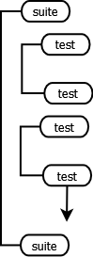
Top level structure of testng
A test is made of one or more classes and a class is made or one or more methods.

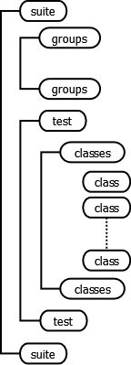
TestNG configuration
Let’s first run a simple testNg.xml which contains just a test class.
simpleTestng.xml:
?
1  2  3  4  5  6  7  8 | <?xml version="1.0" encoding="UTF-8"?>  <suite name="Suite">  <test name="UnitTesting">  <classes>  <class name="com.javarticles.testng.TestA" />  </classes>  </test>  </suite>
As you see our testNg.xml is very simple, it just includes one test class TestA. Few things to note about:
- You can always provide multiple methods of the same annotation type. For example, in the below class, I have two @BeforeSuite methods.
- The annotation methods are allowed to accept some special typed parameters like Method and ITestContext. TestNG takes the responsibility to feed in the runtime object. In our example, beforeTest test method accepts ITestContext, this helps us to know the TestNG’s test section name.
- We all the configuration annotation methods in our test class TestA. This will give us an idea of the sequence in which the methods are invoked.
TestA:
?
1  2  3  4  5  6  7  8  9  10  11  12  13  14  15  16  17  18  19  20  21  22  23  24  25  26  27  28  29  30  31  32  33  34  35  36  37  38  39  40  41  42  43  44  45  46  47  48  49  50  51  52  53  54  55  56  57  58  59  60  61  62  63  64  65  66  67  68  69  70  71  72  73  74  75  76  77  78  79 | package com.javarticles.testng;  import org.testng.ITestContext;  import org.testng.annotations.AfterClass;  import org.testng.annotations.AfterMethod;  import org.testng.annotations.AfterSuite;  import org.testng.annotations.AfterTest;  import org.testng.annotations.BeforeClass;  import org.testng.annotations.BeforeMethod;  import org.testng.annotations.BeforeSuite;  import org.testng.annotations.BeforeTest;  import org.testng.annotations.Test;  public class TestA {  @BeforeSuite  public void beforeSuite1() {  System.out.println("TestA: beforeSuite1");  }  @BeforeSuite  public void beforeSuite2() {  System.out.println("TestA: beforeSuite2");  }  @BeforeTest  public void beforeTest(ITestContext testContext) {  System.out.println("TestA: beforeTest Test<" + testContext.getName() + ">");  }  @BeforeClass  public void beforeClass() {  System.out.println("TestA: beforeClass");  }  @BeforeMethod  public void beforeMethod() {  System.out.println("TestA: beforeMethod");  }  @Test  public void unitTest1A() {  System.out.println("TestA: unitTest1A");  }  @Test(groups="feature1")  public void unitTest2A() {  System.out.println("TestA: unitTest2A, feature1 test");  }  @Test  public void unitTest3A() {  System.out.println("TestA: unitTest3A");  }  @Test(groups="feature2")  public void unitTest4A() {  System.out.println("TestA: unitTest4A, feature2 test");  }  @AfterMethod  public void afterMethod() {  System.out.println("TestA: afterMethod");  }  @AfterClass  public void afterClass() {  System.out.println("TestA: afterClass");  }  @AfterTest  public void afterTest(ITestContext testContext) {  System.out.println("TestA: afterTest Test<" + testContext.getName() + ">");  }  @AfterSuite  public void afterSuite() {  System.out.println("TestA: afterSuite");  }  }
Right click on the testNg.xml file and then click on ‘Run-as->TestNG Suite’.
As you can see from the output, the sequence in which the configurations methods run are:
- @BeforeSuite methods
- @BeforeTest methods
- @BeforeClass methods
- @BeforeMethod methods
- @Test methods
- @AfterMethod methods
- @AfterClass methods
- @AfterTest methods
- @AfterSuite methods
@BeforeMethod, @Test and @AfterMethod repeat for each test method.
Output:
?
1  2  3  4  5  6  7  8  9  10  11  12  13  14  15  16  17  18  19  20  21  22  23  24  25  26  27 | [TestNG] Running:  C:\javarticles_ws\testNGAnnotations\simpleTestng.xml  TestA: beforeSuite1  TestA: beforeSuite2  TestA: beforeTest Test  TestA: beforeClass  TestA: beforeMethod  TestA: unitTest1A  TestA: afterMethod  TestA: beforeMethod  TestA: unitTest2A, feature1 test  TestA: afterMethod  TestA: beforeMethod  TestA: unitTest3A  TestA: afterMethod  TestA: beforeMethod  TestA: unitTest4A, feature2 test  TestA: afterMethod  TestA: afterClass  TestA: afterTest Test  TestA: afterSuite  ===============================================  Suite  Total tests run: 4, Failures: 0, Skips: 0  ===============================================

Multiple tests
You can also run multiple tests together. For example, I can group my tests into ‘Unit Tests’, ‘Functional Tests’ and ‘UI Tests’.
?
1  2  3  4  5  6  7  8  9  10  11  12  13  14  15  16  17  18  19 | <?xml version="1.0" encoding="UTF-8"?>  <suite name="Suite">  <test name="UnitTesting">  <classes>  <class name="com.javarticles.testng.TestA" />  </classes>  </test>  <test name="FunctionalTesting">  <classes>  <class name="com.javarticles.testng.TestA" />  <class name="com.javarticles.testng.TestB" />  </classes>  </test>  <test name="UITesting">  <classes>  <class name="com.javarticles.testng.TestC" />  </classes>  </test>  </suite>
We have added two new test classes TestB and TestC.
TestB:
?
1  2  3  4  5  6  7  8  9  10  11  12  13  14  15  16  17  18  19  20  21  22  23  24  25  26  27  28  29  30  31  32  33  34  35  36  37  38  39  40  41  42  43  44  45  46  47  48  49  50  51  52  53  54  55  56  57  58  59  60  61  62  63  64 | package com.javarticles.testng;  import org.testng.ITestContext;  import org.testng.annotations.AfterGroups;  import org.testng.annotations.AfterMethod;  import org.testng.annotations.AfterSuite;  import org.testng.annotations.AfterTest;  import org.testng.annotations.BeforeGroups;  import org.testng.annotations.BeforeMethod;  import org.testng.annotations.BeforeSuite;  import org.testng.annotations.BeforeTest;  import org.testng.annotations.Test;  public class TestB {  @BeforeSuite  public void beforeSuite() {  System.out.println("TestB: beforeSuite");  }  @BeforeTest  public void beforeTest(ITestContext testContext) {  System.out.println("TestB: beforeTest Test<" + testContext.getName() + ">");  }  @BeforeMethod  public void beforeMethod() {  System.out.println("TestB: beforeMethod");  }  @Test  public void scenario1B() {  System.out.println("TestB: Scenario1B");  }  @Test(groups="feature1")  public void scenario2B() {  System.out.println("TestB: Scenario2B, feature1 test");  }  @AfterMethod  public void afterMethod() {  System.out.println("TestB: afterMethod");  }  @AfterTest  public void afterTest(ITestContext testContext) {  System.out.println("TestB: afterTest Test<" + testContext.getName() + ">");  }  @AfterSuite  public void afterSuite() {  System.out.println("TestB: afterSuite");  }  @BeforeGroups(groups="feature1")  public void beforeGroup() {  System.out.println("TestB: beforeGroup for feature1");  }  @AfterGroups(groups="feature1")  public void afterGroup() {  System.out.println("TestB: afterGroup for feature1");  }  }
TestC:
?
1  2  3  4  5  6  7  8  9  10  11  12  13  14  15  16  17  18  19  20  21  22  23  24  25  26  27  28  29  30  31  32  33  34  35  36  37  38  39  40  41  42  43  44  45  46  47  48  49  50  51  52  53  54  55  56  57  58  59  60  61  62  63  64  65  66  67  68  69 | package com.javarticles.testng;  import org.testng.ITestContext;  import org.testng.annotations.AfterGroups;  import org.testng.annotations.AfterMethod;  import org.testng.annotations.AfterSuite;  import org.testng.annotations.AfterTest;  import org.testng.annotations.BeforeGroups;  import org.testng.annotations.BeforeMethod;  import org.testng.annotations.BeforeSuite;  import org.testng.annotations.BeforeTest;  import org.testng.annotations.Test;  public class TestC {  @BeforeSuite  public void beforeSuite() {  System.out.println("TestC: beforeSuite");  }  @BeforeTest(alwaysRun=true)  public void beforeTest(ITestContext testContext) {  System.out.println("TestC: beforeTest Test<" + testContext.getName() + ">");  }  @BeforeMethod  public void beforeMethod() {  System.out.println("TestC: beforeMethod");  }  @Test  public void uiSceario1C() {  System.out.println("TestC: uiSceario1C");  }  @Test(groups="feature1")  public void uiScenario2C() {  System.out.println("TestC: uiScenario2C, feature1 test");  }  @Test(groups="feature2")  public void uiScenario3C() {  System.out.println("TestC: uiScenario3C, feature2 test");  }  @AfterMethod(groups="feature1")  public void afterMethod() {  System.out.println("TestC: afterMethod");  }  @AfterTest(alwaysRun=true)  public void afterTest(ITestContext testContext) {  System.out.println("TestC: afterTest Test<" + testContext.getName() + ">");  }  @AfterSuite  public void afterSuite() {  System.out.println("TestC: afterSuite");  }  @BeforeGroups(groups="feature2")  public void beforeGroup() {  System.out.println("TestC: beforeGroup for feature2");  }  @AfterGroups(groups="feature2")  public void afterGroup() {  System.out.println("TestC: afterGroup for feature2");  }  }
That’s lot of output! If you note the sequence of execution remains same. We now see couple of new annotation methods @BeforeGroup and @AfterGroup methods. They fire whenever a test method is associated to a group is invoked.
Output:
?
1  2  3  4  5  6  7  8  9  10  11  12  13  14  15  16  17  18  19  20  21  22  23  24  25  26  27  28  29  30  31  32  33  34  35  36  37  38  39  40  41  42  43  44  45  46  47  48  49  50  51  52  53  54  55  56  57  58  59  60  61  62  63  64  65  66  67  68  69  70 | [TestNG] Running:  C:\javarticles_ws\testNGAnnotations\multiTestsTestng.xml  TestA: beforeSuite1  TestA: beforeSuite2  TestB: beforeSuite  TestC: beforeSuite  TestA: beforeTest Test  TestA: beforeClass  TestA: beforeMethod  TestA: unitTest1A  TestA: afterMethod  TestA: beforeMethod  TestA: unitTest2A, feature1 test  TestA: afterMethod  TestA: beforeMethod  TestA: unitTest3A  TestA: afterMethod  TestA: beforeMethod  TestA: unitTest4A, feature2 test  TestA: afterMethod  TestA: afterClass  TestA: afterTest Test  TestA: beforeTest Test  TestB: beforeTest Test  TestA: beforeClass  TestA: beforeMethod  TestA: unitTest1A  TestA: afterMethod  TestB: beforeGroup for feature1  TestA: beforeMethod  TestA: unitTest2A, feature1 test  TestA: afterMethod  TestA: beforeMethod  TestA: unitTest3A  TestA: afterMethod  TestA: beforeMethod  TestA: unitTest4A, feature2 test  TestA: afterMethod  TestA: afterClass  TestB: beforeMethod  TestB: Scenario1B  TestB: afterMethod  TestB: beforeMethod  TestB: Scenario2B, feature1 test  TestB: afterMethod  TestB: afterGroup for feature1  TestA: afterTest Test  TestB: afterTest Test  TestC: beforeTest Test  TestC: beforeMethod  TestC: uiSceario1C  TestC: afterMethod  TestC: beforeMethod  TestC: uiScenario2C, feature1 test  TestC: afterMethod  TestC: beforeGroup for feature2  TestC: beforeMethod  TestC: uiScenario3C, feature2 test  TestC: afterMethod  TestC: afterGroup for feature2  TestC: afterTest Test  TestA: afterSuite  TestB: afterSuite  TestC: afterSuite  ===============================================  Suite  Total tests run: 13, Failures: 0, Skips: 0  ===============================================

Run groups
You can also group your tests based on your feature using <groups> element. For example,
groupTestng.xml:
?
1  2  3  4  5  6  7  8  9  10  11  12  13  14  15  16  17  18  19  20  21  22  23  24  25  26 | <?xml version="1.0" encoding="UTF-8"?>  <suite name="Suite">  <test name="Feature1">  <groups>  <run>  <include name="feature1" />  </run>  </groups>  <classes>  <class name="com.javarticles.testng.TestA" />  <class name="com.javarticles.testng.TestB" />  <class name="com.javarticles.testng.TestC" />  </classes>  </test>  <test name="Feature2">  <groups>  <run>  <include name="feature2" />  </run>  </groups>  <classes>  <class name="com.javarticles.testng.TestA" />  <class name="com.javarticles.testng.TestC" />  </classes>  </test>  </suite>
One thing to note when you are running the groups:
The configuration annotated methods won’t run unless you specify the group in the groups attribute or set alwaysRun to true. For example, in our TestC, we have included both the cases.
?
1  2  3  4  5  6  7  8  9 | @AfterMethod(groups="feature1")  public void afterMethod() {  System.out.println("TestC: afterMethod");  }  @AfterTest(alwaysRun=true)  public void afterTest(ITestContext testContext) {  System.out.println("TestC: afterTest Test<" + testContext.getName() + ">");  }
Output:
?
1  2  3  4  5  6  7  8  9  10  11  12  13  14  15  16  17  18  19  20  21  22 | [TestNG] Running:  C:\javarticles_ws\testNGAnnotations\groupTestng.xml  TestC: beforeTest Test  TestB: beforeGroup for feature1  TestA: unitTest2A, feature1 test  TestB: Scenario2B, feature1 test  TestC: uiScenario2C, feature1 test  TestC: afterMethod  TestB: afterGroup for feature1  TestC: afterTest Test  TestC: beforeTest Test  TestC: beforeGroup for feature2  TestA: unitTest4A, feature2 test  TestC: uiScenario3C, feature2 test  TestC: afterGroup for feature2  TestC: afterTest Test  ===============================================  Suite  Total tests run: 5, Failures: 0, Skips: 0  ===============================================

Example of @Parameters
One of the important features of TestNG is data-driven testing.
One can pass parameter values to test methods as arguments following the below methods:
- Using testng.xml configuration file.
- Through DataProviders
Parameterization is about defining the parameters and its value in testng.xml and then referring to the parameters using @Parameters annotation at method level. The attributes section of @Parameters will have the array of parameters used.
The parameters are defined in testng.xml using the parameter element. Its name and value are specified using the attributes name and value.
paramTestng.xml:
?
1  2  3  4  5  6  7  8  9  10 | <?xml version="1.0" encoding="UTF-8"?>  <suite name="Suite">  <parameter name="param1" value="One"></parameter>  <parameter name="param2" value="1"></parameter>  <test name="ParamTesting">  <classes>  <class name="com.javarticles.testng.TestParam" />  </classes>  </test>  </suite>
Now we use these parameters in the test method.
TestParam:
?
1  2  3  4  5  6  7  8  9  10  11  12  13 | package com.javarticles.testng;  import org.testng.annotations.Parameters;  import org.testng.annotations.Test;  public class TestParam {  @Parameters({"param1", "param2"})  @Test  public void t(String p1, String p2) {  System.out.println("t(" + p1 + ", " + p2 + ")" );  }  }
Output:
?
1  2  3  4  5  6  7  8  9 | [TestNG] Running:  C:\javarticles_ws\testNGAnnotations\paramTestng.xml  t(One, 1)  ===============================================  Suite  Total tests run: 1, Failures: 0, Skips: 0  ===============================================
For more example on @Parameters, click here

Example of @DataProvider
One can provide data using @DataProvider annotated method.The method must return two dimensional object[][] array. The first array represents data set thus takes care of the number of time the tests has to run. The second array represents number of parameters. You can even provide a name to it else by default the method name becomes its name.
If a test is referring to a DataProvider for its parameter values then it has to specify the dataProvider attribute in its Test annotation.
A data-driven test will run once for each set of data passed-in and the data will be provided by the method annotated with @DataProvider.
In the below example, dp() is my data provider method. It returns two sets of data. Each set contains two parameter values. First set is ‘A’ and ‘a’. The second set is ‘B’ and ‘b’.
This is use to inject values to test method alphabets. Since the DataProvider has no name, we refer to it using the method name dp.
TestDataProvider:
?
1  2  3  4  5  6  7  8  9  10  11  12  13  14  15  16 | package com.javarticles.testng;  import org.testng.annotations.DataProvider;  import org.testng.annotations.Test;  public class TestDataProvider {  @Test(dataProvider="dp")  public void alphabets(String upperCase, String lowerCase) {  System.out.println("alphabets(" + upperCase + ", " + lowerCase + ")");  }  @DataProvider  public Object[][] dp() {  return new Object[][]{{"A", "a"}, {"B", "b"}};  }  }
dataProviderTestng.xml:
<?xml version="1.0" encoding="UTF-8"?>
<suite name="Suite">
<test name="DataProviderTesting">
<classes>
<class name="com.javarticles.testng.TestDataProvider" />
</classes>
</test>
</suite>
Output:
?
1  2  3  4  5  6  7  8  9  10 | [TestNG] Running:  C:\javarticles_ws\testNGAnnotations\dataProviderTestng.xml  alphabets(A, a)  alphabets(B, b)  ===============================================  Suite  Total tests run: 2, Failures: 0, Skips: 0  ===============================================
For more examples on @DataProvider, click here

Example of @Factory
We can use TestNG @Factory to create multiple test instances. The test class may either have the default no-arg constructor or constructor with one or more arguments.
In the below example, create is our @Factory method. It creates three instances of TestFactory with different set of data.
TestFactory:
?
1  2  3  4  5  6  7  8  9  10  11  12  13  14  15  16  17  18  19  20  21  22 | package com.javarticles.testng;  import org.testng.annotations.Factory;  import org.testng.annotations.Test;  public class TestFactory {  private String param;  public TestFactory(String param) {  this.param = param;  }  @Test  public void t() {  System.out.println("TestFactory.t:" + param);  }  @Factory  public Object[] create() {  return new Object[] { new TestFactory("one"), new TestFactory("two"), new TestFactory("three")};  }  }
factoryTestng.xml:
?
1  2  3  4  5  6  7  8 | <?xml version="1.0" encoding="UTF-8"?>  <suite name="Suite">  <test name="FactoryTesting">  <classes>  <class name="com.javarticles.testng.TestFactory" />  </classes>  </test>  </suite>
When we run the factoryTestng.xml, we end up running the test case thrice, once for each test instance.
Output:
?
1  2  3  4  5  6  7  8  9  10  11 | [TestNG] Running:  C:\javarticles_ws\testNGAnnotations\factoryTestng.xml  TestFactory.t:two  TestFactory.t:three  TestFactory.t:one  ===============================================  Suite  Total tests run: 3, Failures: 0, Skips: 0  ===============================================
For more examples on @Factory, click here.

Example of @Listeners
In TestNG, all listeners extend the marker interface ITestNGListener. You can register listeners using @Listeners at class level. We specify here an array of test listeners class that extend org.testng.ITestNGListener.
Implement an ISuiteListener.
SuiteListener:
?
1  2  3  4  5  6  7  8  9  10  11  12  13  14  15  16  17  18 | package com.javarticles.testng;  import org.testng.ISuite;  import org.testng.ISuiteListener;  public class SuiteListener implements ISuiteListener {  @Override  public void onStart(ISuite suite) {  System.out.println("Start of suite " + suite.getName());  }  @Override  public void onFinish(ISuite suite) {  System.out.println("Finish of suite " + suite.getName());  }  }
Using Listeners annotation specify the above listener.
TestListener:
?
1  2  3  4  5  6  7  8  9  10  11  12  13 | package com.javarticles.testng;  import org.testng.annotations.Listeners;  import org.testng.annotations.Test;  @Listeners({SuiteListener.class})  public class TestListener {  @Test  public void t() {  System.out.println("test t()" );  }  }
listenerTestng.xml:
?
1  2  3  4  5  6  7  8 | <?xml version="1.0" encoding="UTF-8"?>  <suite name="Suite">  <test name="TestingListener">  <classes>  <class name="com.javarticles.testng.TestListener" />  </classes>  </test>  </suite>
Output:
?
1  2  3  4  5  6  7  8  9  10  11 | [TestNG] Running:  C:\javarticles_ws\testNGAnnotations\listenerTestng.xml  Start of suite Suite  test t()  Finish of suite Suite  ===============================================  Suite  Total tests run: 1, Failures: 0, Skips: 0  ===============================================
One particular pitfall TestNG may cause is, that TestNG does not guarantee that i.e. a @BeforeTest method is directly run before the Test. It only guarantees that it was executed at some point in time before starting the test. (Based on bentolor comments in Reddit).
If you want to run a specific method right before or after the invocation of a test method then implement a IInvokedMethodListener. You need to implement beforeInvocation and afterInvocation, compare the method name to make sure that the test method being invoked (or already invoked) is the one you are interested in.
For example, in the below InvokedTestMethodListenerExample, we want to run a method right before t2() and after t2(). We will implement IInvokedMethodListener and add it to our @Listeners annotation.
InvokedTestMethodListenerExample:
?
1  2  3  4  5  6  7  8  9  10  11  12  13  14  15  16  17  18  19  20  21  22  23  24  25  26  27  28  29  30  31  32  33  34  35  36  37  38  39  40  41  42  43  44  45  46  47  48  49  50 | package com.javarticles.testng;  import org.testng.annotations.AfterTest;  import org.testng.annotations.BeforeTest;  import org.testng.annotations.Listeners;  import org.testng.annotations.Test;  @Listeners(InvokedTestMethodListener.class)  public class InvokedTestMethodListenerExample {  @BeforeTest  public void beforeTest1() {  System.out.println("beforeTest1");  }  @BeforeTest  public void beforeTest2() {  System.out.println("beforeTest2");  }  @Test  public void t1() {  System.out.println("t1");  }  @Test  public void t2() {  System.out.println("t2");  }  @Test  public void t3() {  System.out.println("t3");  }  @Test  public void t4() {  System.out.println("t4");  }  @AfterTest  public void afterTest1() {  System.out.println("afterTest1");  }  @AfterTest  public void afterTest2() {  System.out.println("afterTest2");  }  }
InvokedTestMethodListener:
?
1  2  3  4  5  6  7  8  9  10  11  12  13  14  15  16  17  18  19  20  21  22 | package com.javarticles.testng;  import org.testng.IInvokedMethod;  import org.testng.IInvokedMethodListener;  import org.testng.ITestResult;  public class InvokedTestMethodListener implements IInvokedMethodListener {  @Override  public void beforeInvocation(IInvokedMethod method, ITestResult testResult) {  if ("t2".equals(method.getTestMethod().getMethodName())) {  System.out.println("Invoked just before t2()");  }  }  @Override  public void afterInvocation(IInvokedMethod method, ITestResult testResult) {  if ("t2".equals(method.getTestMethod().getMethodName())) {  System.out.println("Invoked just after t2()");  }  }  }
Output:
?
1  2  3  4  5  6  7  8  9  10  11  12  13  14  15  16  17 | [TestNG] Running:  C:\Users\mokkara\AppData\Local\Temp\testng-eclipse-1301133492\testng-customsuite.xml  beforeTest1  beforeTest2  t1  Invoked just before t2()  t2  Invoked just after t2()  t3  t4  afterTest1  afterTest2  PASSED: t1  PASSED: t2  PASSED: t3  PASSED: t4
For more examples on TestNG listeners, click here
Refrence: http://www.javarticles.com/2015/04/testng-annotations.html

